Financial Risk Analytics- India Credit Default

Submitted by
Renjith Mohan K
09/13/2020

1 Project Objective
The objective of the project is to use logistic regression framework to develop the credit default model. As a part of it, we will be performing the below activities -
EDA
Outlier Treatment
Missing Value Treatment
New Variables Creation (One ration for profitability, leverage, liquidity and company's size each )
Check for multicollinearity
Univariate & bivariate analysis
Modeling
Build Logistic Regression Model on most important variables
Analyze coefficient & their signs
Model Performance Measures
Predict accuracy of model on dev and validation datasets
Sort the data in descending order based on probability of default and then divide into 10 dociles based on probability & check how well the model has performed

2 Assumptions
NA

3.1 Environment Set up and Data Import
3.1.1 Install necessary Packages and Invoke Libraries
As a part of this problem, we installed the below packages and afterwards loaded into library with the aid of library() function.

library(ggplot2)
library(readxl)
library(car)
library(corrplot)
library(caTools)
library(ROCR)
library(ineq)
library(caret)
library(blorr)

Please refer Appendix A for Source Code

3.1.2 Set up working Directory
Setting a working directory on starting of the R session makes importing and exporting data
files and code files easier. Here the working directory is chosen as C:/2020/Finance_Risk_Analytics where we have the data sets, codes etc. related to the project. We do this with the aid of setwd() function.

Please refer Appendix A for Source Code

3.1.3 Import and Read the Dataset
The given dataset is in .xlsx format. Hence, the command “read_excel” is used for importing the
file.

Please refer Appendix A for Source Code.

3.2 EDA - Basic data summary, Univariate, Bivariate analysis, graphs

Approach: For basic data summary /variable identification, we use the R functions - dim, names, str, summary, head, tail. The purpose of each of the functions are briefly mentioned below -

dim - we use this to get the dimension of the data frame meaning the number of rows and columns.
names - we use this to identify the colum/variable names. For this data set , we make changes to the column names accordingly.
str - we use this to get the structure of the variable/column names like factor, integer or numeric.
summary - we use this to get a summary of the column names. It gives us the 5 point summary with details of min, max. Median, 25th percentile & 75th percentile.Basically we perform descriptive statistic with this one.
head - we use this to check a sample of data from the data frame. By default it gives the first 6 records.
tail - we use this also to check sample records from the data frame. By default it gives the last 6 records.

Please refer Appendix A for Source Code.

3.2.1 EDA - Basic data Inference

Below are the inferences from the above EDA step -

Using “dim”, we identified that the Factor Hair data set has 3541 rows and 52 columns. We also verified that the column names are proper and from “str” command, some variables are numeric and character in nature. We will convert character to numeric.We notice that some of the independent variables and the dependent variable are in fact factors and . We also confirmed that the data is proper by checking first and last 6 records by using the head and tail functions.

> dim(data1)[1] 3541 52

> summary(data1) Total assets Net worth Total income Change in stock Total expenses Profit after tax PBDITA
Min. : 0.1 Min. : 0.0 Min. : 0.0 Min. :-44.19 Min. : -0.1 Min. :-76.8 Min. :-205.4
1st Qu.: 91.3 1st Qu.: 31.3 1st Qu.: 121.2 1st Qu.: -0.70 1st Qu.: 104.1 1st Qu.: 0.6 1st Qu.: 7.3
Median : 309.7 Median : 102.3 Median : 510.9 Median : 4.10 Median : 458.7 Median : 10.0 Median : 41.1
Mean :1553.9 Mean : 559.3 Mean :1745.2 Mean : 23.65 Mean :1633.3 Mean :103.0 Mean : 223.4
3rd Qu.:1098.7 3rd Qu.: 377.3 3rd Qu.:1745.2 3rd Qu.: 23.65 3rd Qu.:1618.9 3rd Qu.: 64.2 3rd Qu.: 184.2
Max. :8452.9 Max. :3034.4 Max. :9339.7 Max. :171.68 Max. :8769.8 Max. :595.1 Max. :1237.9
PBT Cash profit PBDITA as % of total income PBT as % of total income PAT as % of total income
Min. :-101.5 Min. :-132.5 Min. :-11.30 Min. :-22.248 Min. :-21.722
1st Qu.: 0.9 1st Qu.: 3.1 1st Qu.: 5.07 1st Qu.: 0.600 1st Qu.: 0.390
Median : 14.2 Median : 21.8 Median : 9.80 Median : 3.460 Median : 2.454
Mean : 137.4 Mean : 145.5 Mean : 11.47 Mean : 3.999 Mean : 2.454
3rd Qu.: 89.5 3rd Qu.: 112.7 3rd Qu.: 16.15 3rd Qu.: 8.630 3rd Qu.: 6.250
Max. : 776.1 Max. : 823.7 Max. : 34.61 Max. : 23.170 Max. : 18.170
Cash profit as % of total income PAT as % of net worth Sales Income from financial services Other income
Min. :-10.700 Min. :-30.09 Min. : 0.1 Min. : 0.0 Min. : 0.00
1st Qu.: 2.090 1st Qu.: 0.00 1st Qu.: 133.3 1st Qu.: 0.7 1st Qu.: 0.80
Median : 5.770 Median : 7.92 Median : 531.9 Median : 6.2 Median : 8.00
Mean : 6.617 Mean : 10.66 Mean :1731.0 Mean : 26.7 Mean :11.61
3rd Qu.: 10.560 3rd Qu.: 20.19 3rd Qu.:1731.0 3rd Qu.: 26.7 3rd Qu.:11.61
Max. : 24.514 Max. : 50.46 Max. :9224.9 Max. :144.2 Max. :67.88
Total capital Reserves and funds Borrowings Current liabilities & provisions Deferred tax liability
Min. : 0.1 Min. :-389.5 Min. : 0.1 Min. : 0.1 Min. : 0.10
1st Qu.: 13.1 1st Qu.: 5.8 1st Qu.: 29.7 1st Qu.: 18.7 1st Qu.: 6.70
Median : 42.2 Median : 58.9 Median : 127.3 Median : 74.2 Median : 46.50
Mean :119.0 Mean : 487.7 Mean : 528.7 Mean : 383.9 Mean : 84.18
3rd Qu.:100.5 3rd Qu.: 331.0 3rd Qu.: 528.7 3rd Qu.: 299.6 3rd Qu.: 84.18
Max. :608.8 Max. :2789.1 Max. :2948.0 Max. :2094.5 Max. :480.90
Shareholders funds Cumulative retained profits Capital employed TOL/TNW
Min. : 0.0 Min. :-288.2 Min. : 0.0 Min. :-2.410
1st Qu.: 32.0 1st Qu.: 1.3 1st Qu.: 60.8 1st Qu.: 0.600
Median : 105.6 Median : 38.3 Median : 214.7 Median : 1.430
Mean : 579.5 Mean : 357.2 Mean :1085.1 Mean : 2.411
3rd Qu.: 393.2 3rd Qu.: 214.6 3rd Qu.: 767.3 3rd Qu.: 2.830
Max. :3160.0 Max. :2069.9 Max. :5988.7 Max. :10.530
Total term liabilities / tangible net worth Contingent liabilities / Net worth (%) Contingent liabilities Net fixed assets
Min. :-1.2500 Min. : 0.00 Min. : 0.1 Min. : 0.0
1st Qu.: 0.0500 1st Qu.: 0.00 1st Qu.: 16.0 1st Qu.: 27.3
Median : 0.3400 Median : 5.33 Median : 194.3 Median : 101.0
Mean : 0.8236 Mean : 27.87 Mean : 319.7 Mean : 507.6
3rd Qu.: 1.0000 3rd Qu.: 30.76 3rd Qu.: 319.7 3rd Qu.: 401.1
Max. : 4.2000 Max. :151.04 Max. :1846.8 Max. :2811.0
Investments Current assets Net working capital Quick ratio (times) Current ratio (times)
Min. : 0.0 Min. : 0.1 Min. :-159.7 Min. :0.0000 Min. :0.000
1st Qu.: 4.6 1st Qu.: 37.2 1st Qu.: -1.0 1st Qu.:0.4200 1st Qu.:0.940
Median : 233.0 Median : 151.0 Median : 16.7 Median :0.6800 Median :1.240
Mean : 233.0 Mean : 620.1 Mean : 103.1 Mean :0.8854 Mean :1.517
3rd Qu.: 233.0 3rd Qu.: 541.5 3rd Qu.: 87.7 3rd Qu.:1.0200 3rd Qu.:1.690
Max. :1252.4 Max. :3327.1 Max. : 679.0 Max. :2.9800 Max. :4.250
Debt to equity ratio (times) Cash to current liabilities (times) Cash to average cost of sales per day Creditors turnover
Min. :0.00 Min. :0.0000 Min. : 0.00 Min. : 0.00
1st Qu.:0.22 1st Qu.:0.0200 1st Qu.: 2.89 1st Qu.: 3.94
Median :0.79 Median :0.0700 Median : 8.37 Median : 6.72
Mean :1.44 Mean :0.2404 Mean : 35.18 Mean :11.01
3rd Qu.:1.75 3rd Qu.:0.2100 3rd Qu.: 24.82 3rd Qu.:11.01
Max. :6.75 Max. :1.2500 Max. :190.48 Max. :44.50
Debtors turnover Finished goods turnover WIP turnover Raw material turnover Shares outstanding Equity face value
Min. : 0.00 Min. : -0.09 Min. :-0.18 Min. :-2.000 Min. : 50 Min. : 6.20
1st Qu.: 4.01 1st Qu.: 10.21 1st Qu.: 5.93 1st Qu.: 3.410 1st Qu.: 2209860 1st Qu.: 10.00
Median : 7.05 Median : 25.80 Median :13.14 Median : 7.300 Median : 6297477 Median : 10.00
Mean :10.92 Mean : 42.30 Mean :18.50 Mean : 9.243 Mean :15349391 Mean : 19.03
3rd Qu.:10.92 3rd Qu.: 42.30 3rd Qu.:18.50 3rd Qu.:10.920 3rd Qu.:15349391 3rd Qu.: 19.03
Max. :45.49 Max. :201.99 Max. :77.28 Max. :34.812 Max. :79982549 Max. :100.00
EPS Adjusted EPS PE on BSE Default Current Ratio Profit Margin Borrowings Ratio
Min. :-14.24 Min. :-10.88 Min. :-27.09 0:3307 Min. : 0.000 Min. : -97.0000 Min. : 0.000
1st Qu.: 0.00 1st Qu.: 0.00 1st Qu.: 13.01 1: 234 1st Q

str(data1)tibble [3,541 x 52] (S3: tbl_df/tbl/data.frame)
$ Num : num [1:3541] 1 2 3 4 5 6 7 8 9 10 ...
$ Networth Next Year : num [1:3541] 8890.6 394.3 92.2 2.7 109 ...
$ Total assets : num [1:3541] 17512.3 941 232.8 2.7 478.5 ...
$ Net worth : num [1:3541] 7093.2 351.5 100.6 2.7 107.6 ...
$ Total income : num [1:3541] 24965 1527 477 NA 1580 ...
$ Change in stock : num [1:3541] 235.8 42.7 -5.2 NA -17 ...
$ Total expenses : num [1:3541] 23658 1455 479 NA 1558 ...
$ Profit after tax : num [1:3541] 1543.2 115.2 -6.6 NA 5.5 ...
$ PBDITA : num [1:3541] 2860.2 283 5.8 NA 31 ...
$ PBT : num [1:3541] 2417.2 188.4 -6.6 NA 6.3 ...

names(data1) [1] "Num" "Networth Next Year"
[3] "Total assets" "Net worth"
[5] "Total income" "Change in stock"
[7] "Total expenses" "Profit after tax"
[9] "PBDITA" "PBT"
[11] "Cash profit" "PBDITA as % of total income"
[13] "PBT as % of total income" "PAT as % of total income"
[15] "Cash profit as % of total income" "PAT as % of net worth"
[17] "Sales" "Income from financial services"
[19] "Other income" "Total capital"
[21] "Reserves and funds" "Deposits (accepted by commercial banks)"
[23] "Borrowings" "Current liabilities & provisions"
[25] "Deferred tax liability" "Shareholders funds"
[27] "Cumulative retained profits" "Capital employed"
[29] "TOL/TNW" "Total term liabilities / tangible net worth"
[31] "Contingent liabilities / Net worth (%)" "Contingent liabilities"
[33] "Net fixed assets" "Investments"
[35] "Current assets" "Net working capital"
[37] "Quick ratio (times)" "Current ratio (times)"
[39] "Debt to equity ratio (times)" "Cash to current liabilities (times)"
[41] "Cash to average cost of sales per day" "Creditors turnover"
[43] "Debtors turnover" "Finished goods turnover"
[45] "WIP turnover" "Raw material turnover"
[47] "Shares outstanding" "Equity face value"
[49] "EPS" "Adjusted EPS"
[51] "Total liabilities" "PE on BSE"

# Remove Deposits as it is empty and Num columns as it is just serial numbers
> data1 <- data1[c(-1,-22)]

# Convert the below 8 character variables to numeric
-Creditors turnover, Debtors turnover, Finished goods turnover, WIP turnover, Raw material turnover , Shares outstanding,Equity face value, PE on BSE
> data1$`Creditors turnover`<- as.numeric(data1$`Creditors turnover`)> data1$`Debtors turnover` <- as.numeric(data1$`Debtors turnover`)> data1$`Finished goods turnover`<- as.numeric(data1$`Finished goods turnover`)> data1$`WIP turnover` <- as.numeric(data1$`WIP turnover`)
> data1$`Raw material turnover`<- as.numeric(data1$`Raw material turnover`)
> data1$`Shares outstanding` <- as.numeric(data1$`Shares outstanding`)> data1$`Equity face value`<- as.numeric(data1$`Equity face value`)> data1$`PE on BSE`<- as.numeric(data1$`PE on BSE`)

#Creating the Target variable-Default from the variable-Networth Next Year and convert it to a factor
> data1$Default <- ifelse(data1$`Networth Next Year` >= 0, 0, 1)
> data1$Default<- as.factor(data1$Default)

Please refer Appendix A for Source Code.

Outlier Treatment

We check for outliers using boxplot$stats and we do a treatment to remove those values from the dataset. It looks like most of the variables have outliers and so we go with treatment

The treatment is done in such a way that any value greater than 75th percentile + 1.5 * IQR is limited to 95th percentile value and all values lower than 25th percentile - 1.5 *IQR is limited to 5th percentile.

#Checking for Outliers> sapply(data1[c(-1,-51)], function(x) {length(boxplot.stats(x)$out)}) Total assets Net worth
484 499
Total income Change in stock
427 621
Total expenses Profit after tax
432 577
PBDITA PBT
483 576
Cash profit PBDITA as % of total income
515 287
PBT as % of total income PAT as % of total income
453 502
Cash profit as % of total income PAT as % of net worth
353 344
Sales Income from financial services
417 429
Other income Total capital
317 444
Reserves and funds Borrowings
526 432
Current liabilities & provisions Deferred tax liability
482 331
Shareholders funds Cumulative retained profits
495 575
Capital employed TOL/TNW
477 335
Total term liabilities / tangible net worth Contingent liabilities / Net worth (%)
328 391
Contingent liabilities Net fixed assets
327 468
Investments Current assets
363 451
Net working capital Quick ratio (times)
672 313
Current ratio (times) Debt to equity ratio (times)
335 310
Cash to current liabilities (times) Cash to average cost of sales per day
452 483
Creditors turnover Debtors turnover
369 336
Finished goods turnover WIP turnover
326 316
Raw material turnover Shares outstanding
247 393
Equity face value EPS
436 540
Adjusted EPS Total liabilities
582 484
PE on BSE
201

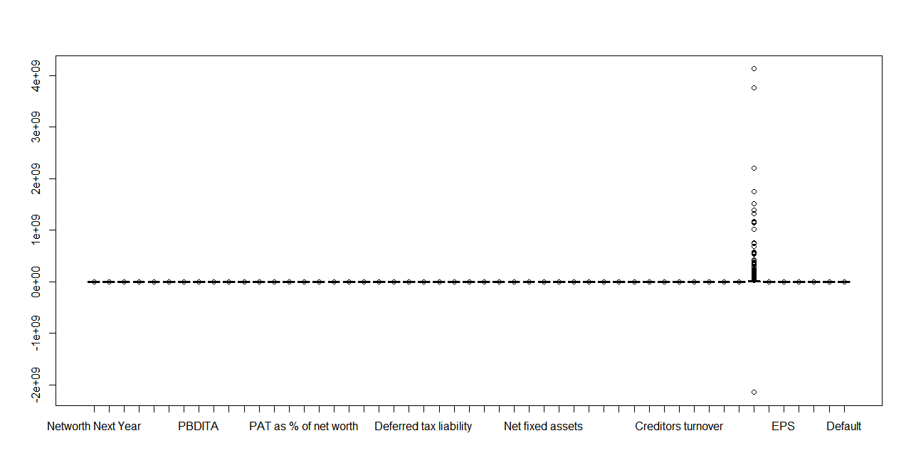

Outlier Treatment using Outlier function

> Outlier <- function(x){+
qnt <- quantile(x, probs=c(.25, .75), na.rm = T)+
caps <- quantile(x, probs=c(.05, .95), na.rm = T)+
H <- 1.5 * IQR(x, na.rm = T)+
x[x < (qnt[1] - H)] <- caps[1]+ x[x > (qnt[2] + H)] <- caps[2]+
return(x)+ }

data1$`Total assets` <- Outlier(data1$`Total assets`)
> data1$`Net worth` <- Outlier(data1$`Net worth`) > data1$`Total income`<- Outlier(data1$`Total income`) > data1$`Change in stock`<- Outlier(data1$`Change in stock`) > data1$`Total expenses`<- Outlier(data1$`Total expenses`) > data1$`Profit after tax`<- Outlier(data1$`Profit after tax`) > data1$PBDITA<- Outlier(data1$PBDITA) > data1$PBT<- Outlier(data1$PBT) > data1$`Cash profit`<- Outlier(data1$`Cash profit`) > data1$`PBDITA as % of total income`<- Outlier(data1$`PBDITA as % of total income`) > data1$`PBT as % of total income`<- Outlier(data1$`PBT as % of total income`) > data1$`PAT as % of total income`<- Outlier(data1$`PAT as % of total income`) > data1$`Cash profit as % of total income`<- Outlier(data1$`Cash profit as % of total income`) > data1$`PAT as % of net worth`<- Outlier(data1$`PAT as % of net worth`) > data1$Sales<- Outlier(data1$Sales) > data1$`Income from financial services`<- Outlier(data1$`Income from financial services`) > data1$`Other income`<- Outlier(data1$`Other income`) > data1$`Total capital`<- Outlier(data1$`Total capital`) > data1$`Reserves and funds`<- Outlier(data1$`Reserves and funds`) > data1$Borrowings<- Outlier(data1$Borrowings) > data1$`Current liabilities & provisions`<- Outlier(data1$`Current liabilities & provisions`)> data1$`Deferred tax liability`<- Outlier(data1$`Deferred tax liability`) > data1$`Shareholders funds`<- Outlier(data1$`Shareholders funds`) > data1$`Cumulative retained profits`<- Outlier(data1$`Cumulative retained profits`) > data1$`Capital employed`<- Outlier(data1$`Capital employed`) > data1$`TOL/TNW`<- Outlier(data1$`TOL/TNW`) > data1$`Total term liabilities / tangible net worth`<- Outlier(data1$`Total term liabilities / tangible net worth`) > data1$`Contingent liabilities / Net worth (%)`<- Outlier(data1$`Contingent liabilities / Net worth (%)`) > data1$`Contingent liabilities`<- Outlier(data1$`Contingent liabilities`) > data1$`Net fixed assets`<- Outlier(data1$`Net fixed assets`) > data1$Investments<- Outlier(data1$Investments) > data1$`Current assets`<- Outlier(data1$`Current assets`) > data1$`Net working capital`<- Outlier(data1$`Net working capital`) > data1$`Quick ratio (times)`<- Outlier(data1$`Quick ratio (times)`) > data1$`Current ratio (times)`<- Outlier(data1$`Current ratio (times)`) > data1$`Debt to equity ratio (times)`<- Outlier(data1$`Debt to equity ratio (times)`) > data1$`Cash to current liabilities (times)`<- Outlier(data1$`Cash to current liabilities (times)`) > data1$`Cash to average cost of sales per day`<- Outlier(data1$`Cash to average cost of sales per day`) > data1$`Creditors turnover`<- Outlier(data1$`Creditors turnover`) > data1$`Debtors turnover`<- Outlier(data1$`Debtors turnover`) > data1$`Finished goods turnover`<- Outlier(data1$`Finished goods turnover`) > data1$`WIP turnover`<- Outlier(data1$`WIP turnover`) > data1$`Raw material turnover`<- Outlier(data1$`Raw material turnover`) > data1$`Shares outstanding`<- Outlier(data1$`Shares outstanding`) > data1$`Equity face value`<- Outlier(data1$`Equity face value`) > data1$`EPS`<- Outlier(data1$`EPS`) > data1$`Adjusted EPS`<- Outlier(data1$`Adjusted EPS`) > data1$`Total liabilities`<- Outlier(data1$`Total liabilities`) > data1$`PE on BSE`<- Outlier(data1$`PE on BSE`)

Missing Value Treatment

It seems most of the variables have missing values. So we use a mean imputation for the same.

#Check for Missing Values (NA)> sapply(data1,function(x) sum(is.na(x))) Total assets Net worth
0 0
Total income Change in stock
198 458
Total expenses Profit after tax
139 131
PBDITA PBT
131 131
Cash profit PBDITA as % of total income
131 68
PBT as % of total income PAT as % of total income
68 68
Cash profit as % of total income PAT as % of net worth
68 0
Sales Income from financial services
259 935
Other income Total capital
1295 4
Reserves and funds Borrowings
85 366
Current liabilities & provisions Deferred tax liability
96 1140
Shareholders funds Cumulative retained profits
0 38
Capital employed TOL/TNW
0 0
Total term liabilities / tangible net worth Contingent liabilities / Net worth (%)
0 0
Contingent liabilities Net fixed assets
1188 118
Investments Current assets
1435 66
Net working capital Quick ratio (times)
32 93
Current ratio (times) Debt to equity ratio (times)
93 0
Cash to current liabilities (times) Cash to average cost of sales per day
93 85
Creditors turnover Debtors turnover
333 328
Finished goods turnover WIP turnover
740 640
Raw material turnover Shares outstanding
361 692
Equity face value EPS
692 0
Adjusted EPS Total liabilities
0 0
PE on BSE Default
2194 0
>

Missing Value treatment
---------------------

data1$`Change in stock`[which(is.na(data1$`Change in stock`))] <- mean(data1$`Change in stock`,na.rm=T)
> data1$`Total income`[which(is.na(data1$`Total income`))] <- mean(data1$`Total income`,na.rm=T)
> > data1$`Change in stock`[which(is.na(data1$`Change in stock`))] <- mean(data1$`Change in stock`,na.rm=T)
>
> data1$`Total expenses`[which(is.na(data1$`Total expenses`))] <- mean(data1$`Total expenses`,na.rm=T)> > data1$`Profit after tax`[which(is.na(data1$`Profit after tax`))] <- mean(data1$`Profit after tax`,na.rm=T)> > data1$PBDITA[which(is.na(data1$PBDITA))] <- mean(data1$PBDITA,na.rm=T)> > data1$PBT[which(is.na(data1$PBT))] <- mean(data1$PBT,na.rm=T)> > data1$`Cash profit`[which(is.na(data1$`Cash profit`))] <- mean(data1$`Cash profit`,na.rm=T)> > data1$`PBDITA as % of total income`[which(is.na(data1$`PBDITA as % of total income`))] <- mean(data1$`PBDITA as % of total income`,na.rm=T)> > data1$`PBT as % of total income`[which(is.na(data1$`PBT as % of total income`))] <- mean(data1$`PBT as % of total income`,na.rm=T)> > data1$`PAT as % of total income`[which(is.na(data1$`PAT as % of total income`))] <- mean(data1$`PAT as % of total income`,na.rm=T)> > data1$`Cash profit as % of total income`[which(is.na(data1$`Cash profit as % of total income`))] <- mean(data1$`Cash profit as % of total income`,na.rm=T)> > data1$Sales[which(is.na(data1$Sales))] <- mean(data1$Sales,na.rm=T)> > data1$`Income from financial services`[which(is.na(data1$`Income from financial services`))] <- mean(data1$`Income from financial services`,na.rm=T)> > data1$`Other income`[which(is.na(data1$`Other income`))] <- mean(data1$`Other income`,na.rm=T)> > data1$`Total capital`[which(is.na(data1$`Total capital`))] <- mean(data1$`Total capital`,na.rm=T)> > data1$`Reserves and funds`[which(is.na(data1$`Reserves and funds`))] <- mean(data1$`Reserves and funds`,na.rm=T)> > data1$Borrowings[which(is.na(data1$Borrowings))] <- mean(data1$Borrowings,na.rm=T)> > data1$`Current liabilities & provisions`[which(is.na(data1$`Current liabilities & provisions`))] <- mean(data1$`Current liabilities & provisions`,na.rm=T)> > data1$`Deferred tax liability`[which(is.na(data1$`Deferred tax liability`))] <- mean(data1$`Deferred tax liability`,na.rm=T)> > data1$`Cumulative retained profits`[which(is.na(data1$`Cumulative retained profits`))] <- mean(data1$`Cumulative retained profits`,na.rm=T)> > data1$`Contingent liabilities`[which(is.na(data1$`Contingent liabilities`))] <- mean(data1$`Contingent liabilities`,na.rm=T)> > data1$`Net fixed assets`[which(is.na(data1$`Net fixed assets`))] <- mean(data1$`Net fixed assets`,na.rm=T)> > data1$Investments[which(is.na(data1$Investments))] <- mean(data1$Investments,na.rm=T)> > data1$`Current assets`[which(is.na(data1$`Current assets`))] <- mean(data1$`Current assets`,na.rm=T)> > data1$`Net working capital`[which(is.na(data1$`Net working capital`))] <- mean(data1$`Net working capital`,na.rm=T)> > data1$`Quick ratio (times)`[which(is.na(data1$`Quick ratio (times)`))] <- mean(data1$`Quick ratio (times)`,na.rm=T)> > data1$`Current ratio (times)`[which(is.na(data1$`Current ratio (times)`))] <- mean(data1$`Current ratio (times)`,na.rm=T)> > data1$`Cash to current liabilities (times)`[which(is.na(data1$`Cash to current liabilities (times)`))] <- mean(data1$`Cash to current liabilities (times)`,na.rm=T)> > data1$`Cash to average cost of sales per day`[which(is.na(data1$`Cash to average cost of sales per day`))] <- mean(data1$`Cash to average cost of sales per day`,na.rm=T)> > data1$`Creditors turnover`[which(is.na(data1$`Creditors turnover`))] <- mean(data1$`Creditors turnover`,na.rm=T)> > data1$`Debtors turnover`[which(is.na(data1$`Debtors turnover`))] <- mean(data1$`Debtors turnover`,na.rm=T)> > data1$`Finished goods turnover`[which(is.na(data1$`Finished goods turnover`))] <- mean(data1$`Finished goods turnover`,na.rm=T)> > data1$`WIP turnover`[which(is.na(data1$`WIP turnover`))] <- mean(data1$`WIP turnover`,na.rm=T)> > data1$`Raw material turnover`[which(is.na(data1$`Raw material turnover`))] <- mean(data1$`Raw material turnover`,na.rm=T)> > data1$`Equity face value`[which(is.na(data1$`Equity face value`))] <- mean(data1$`Equity face value`,na.rm=T)> > data1$`Adjusted EPS`[which(is.na(data1$`Adjusted EPS`))] <- mean(data1$`Adjusted EPS`,na.rm=T)> > data1$`PE on BSE`[which(is.na(data1$`PE on BSE`))] <- mean(data1$`PE on BSE`,na.rm=T)> > data1$`Shares outstanding`[which(is.na(data1$`Shares outstanding`))] <- mean(data1$`Shares outstanding`,na.rm=T)

Check again for missing values again :
We can see that all missing values are moved out now
#Check again for Missing values> sapply(data1,function(x) sum(is.na(x))) Total assets Net worth
0 0
Total income Change in stock
0 0
Total expenses Profit after tax
0 0
PBDITA PBT
0 0
Cash profit PBDITA as % of total income
0 0
PBT as % of total income PAT as % of total income
0 0
Cash profit as % of total income PAT as % of net worth
0 0
Sales Income from financial services
0 0
Other income Total capital
0 0
Reserves and funds Borrowings
0 0
Current liabilities & provisions Deferred tax liability
0 0
Shareholders funds Cumulative retained profits
0 0
Capital employed TOL/TNW
0 0
Total term liabilities / tangible net worth Contingent liabilities / Net worth (%)
0 0
Contingent liabilities Net fixed assets
0 0
Investments Current assets
0 0
Net working capital Quick ratio (times)
0 0
Current ratio (times) Debt to equity ratio (times)
0 0
Cash to current liabilities (times) Cash to average cost of sales per day
0 0
Creditors turnover Debtors turnover
0 0
Finished goods turnover WIP turnover
0 0
Raw material turnover Shares outstanding
0 0
Equity face value EPS
0 0
Adjusted EPS Total liabilities
0 0
PE on BSE Default
0 0

Creating New Variables
We will create 4 new variables one each from the categories - Liquidity, Profitability, Leverage and company size.

#Liquidity - Current Ratio = Current Assets/Current Liabilities> data1$`Current Ratio` = data1$`Current assets`/data1$`Current liabilities & provisions`>
#Profitability - Profit Margin = Profit after tax /sales> data1$`Profit Margin` = data1$`Profit after tax`/data1$Sales>
#Leverage - Borrowings Ratio = Borrowings/Total Liabilities> data1$`Borrowings Ratio` = data1$Borrowings/data1$`Total liabilities`>
#Company Size - Net Fixed Assets to Net worth ratio = Fixed Assets/Net Worth> data1$`Assets_Worth Ratio` = data1$`Net fixed assets`/data1$`Net worth`

Check for Multi-collinearity

We can check for multi collinearity using a cor() function .
The results below clearly shows that multi collinearity exists in the data set as we could find a number of variables with a correlation coefficant of more than 0.7

#Check for multicollinearity> cor(data1[,-c(50)])
Total assets Net worth Total income Change in stock Total expenses
Total assets 1.000000000 0.869282610 0.854678880 4.195976e-01 0.853938175
Net worth 0.869282610 1.000000000 0.783574092 3.944205e-01 0.776493932
Total income 0.854678880 0.783574092 1.000000000 4.186643e-01 0.984804253
Change in stock 0.419597613 0.394420540 0.418664290 1.000000e+00 0.431877018
Total expenses 0.853938175 0.776493932 0.984804253 4.318770e-01 1.000000000
Profit after tax 0.720977065 0.768496517 0.740548925 3.897910e-01 0.721846155
PBDITA 0.843457633 0.832345914 0.840184590 4.112672e-01 0.827999978
PBT 0.723287465 0.768140422 0.747063202 3.938130e-01 0.730186497
Cash profit 0.795915404 0.814100780 0.797049145 4.098708e-01 0.785179860
PBDITA as % of total income 0.164488597 0.216275414 0.079806961 8.950858e-02 0.065701145
PBT as % of total income 0.183812910 0.252202211 0.190680998 1.203957e-01 0.173266731
PAT as % of total income 0.165571222 0.229039707 0.177200212 1.081374e-01 0.160598784
Cash profit as % of total income 0.158712441 0.226087661 0.111540557 1.018083e-01 0.098774819
PAT as % of net worth 0.198808100 0.223128051 0.243071309 1.526312e-01 0.241085565
Sales 0.846682456 0.778866324 0.988973288 4.269955e-01 0.980518126
Income from financial services 0.616439732 0.649807076 0.569396293 2.740782e-01 0.561215709
Other income 0.532681665 0.496507600 0.546517207 2.740394e-01 0.537025093
Total capital 0.651835495 0.596670919 0.588947207 2.894977e-01 0.590080250
Profit after tax PBDITA PBT Cash profit
Total assets 0.720977065 0.843457633 0.723287465 0.795915404
Net worth 0.768496517 0.832345914 0.768140422 0.814100780
Total income 0.740548925 0.840184590 0.747063202 0.797049145
Change in stock 0.389790994 0.411267177 0.393812969 0.409870777
Total expenses 0.721846155 0.827999978 0.730186497 0.785179860
Profit after tax 1.000000000 0.878248898 0.961213918 0.901652507
PBDITA 0.878248898 1.000000000 0.887922430 0.945896011
PBT 0.961213918 0.887922430 1.000000000 0.899419352
Cash profit 0.901652507 0.945896011 0.899419352 1.000000000
PBDITA as % of total income 0.293812169 0.265246836 0.294259609 0.276094783
PBT as % of total income 0.394455185 0.324521596 0.396595231 0.349793950
PAT as % of total income 0.368181604 0.297362505 0.362105146 0.325330857
Cash profit as % of total income 0.317120862 0.269145905 0.310081862 0.320210233
PAT as % of net worth 0.427148604 0.342641546 0.424773136 0.378632074
Sales 0.736456708 0.832369521 0.742897988 0.795277657
Income from financial services 0.547801236 0.600422454 0.537373389 0.587733965
Other income 0.444233758 0.512660852 0.444693179 0.487223471
Total capital 0.473738617 0.574268982 0.473765403 0.546929285
PBDITA as % of total income PBT as % of total income
Total assets 0.164488597 0.18381291
Net worth 0.216275414 0.25220221
Total income 0.079806961 0.19068100
Change in stock 0.089508580 0.12039566
Total expenses 0.065701145 0.17326673
Profit after tax 0.293812169 0.39445518
PBDITA 0.265246836 0.32452160
PBT 0.294259609 0.39659523
Cash profit 0.276094783 0.34979395
PBDITA as % of total income 1.000000000 0.70277151
PBT as % of total income 0.702771508 1.00000000
PAT as % of total income 0.651498130 0.96804036
Cash profit as % of total income 0.854838272 0.81642140
PAT as % of net worth 0.444449889 0.67605005
Sales 0.080566444 0.18387817
Income from financial services 0.171434535 0.18152061
Other income 0.094435245 0.11307887
Total capital 0.133094074 0.06728596
PAT as % of total income Cash profit as % of total income
Total assets 0.1655712215 0.158712441
Net worth 0.2290397073 0.226087661
Total income 0.1772002122 0.111540557
Change in stock 0.1081374402 0.101808309
Total expenses 0.1605987839 0.098774819
Profit after tax 0.3681816044 0.317120862
PBDITA 0.2973625049 0.269145905
PBT 0.3621051461 0.310081862
Cash profit 0.3253308571 0.320210233
PBDITA as % of total income 0.6514981296 0.854838272
PBT as % of total income 0.9680403614 0.816421395
PAT as % of total income 1.0000000000 0.786284945
Cash profit as % of total income 0.7862849445 1.000000000
PAT as % of net worth 0.6747810618 0.541340146
Sales 0.1689643369 0.112052533
Income from financial services 0.1695667539 0.168856827
Other income 0.0945251844 0.090251131
Total capital 0.0535621816 0.095132567
PAT as % of net worth Sales Income from financial services
Total assets 0.198808100 0.846682456 0.6164397320
Net worth 0.223128051 0.778866324 0.6498070761
Total income 0.243071309 0.988973288 0.5693962928
Change in stock 0.152631226 0.426995495 0.2740782041
Total expenses 0.241085565 0.980518126 0.5612157085
Profit after tax 0.427148604 0.736456708 0.5478012356
PBDITA 0.342641546 0.832369521 0.6004224536
PBT 0.424773136 0.742897988 0.5373733894
Cash profit 0.378632074 0.795277657 0.5877339650
PBDITA as % of total income 0.444449889 0.080566444 0.1714345345
PBT as % of total income 0.676050049 0.183878170 0.1815206095
PAT as % of total income 0.674781062 0.168964337 0.1695667539
Cash profit as % of total income 0.541340146 0.112052533 0.1688568271
PAT as % of net worth 1.000000000 0.236481623 0.1275632251
Sales 0.236481623 1.000000000 0.5645718964
Income from financial services 0.127563225 0.564571896 1.0000000000
Other income 0.095846147 0.536943299 0.4410803752
Total capital 0.090803649 0.578989828 0.4281563376
Other income Total capital Reserves and funds Borrowings
Total assets 0.5326816650 0.651835495 0.811626965 0.7867471912
Net worth 0.4965076003 0.596670919 0.915235401 0.6430879432
Total income 0.5465172066 0.588947207 0.753853086 0.6799872734
Change in stock 0.2740393630 0.289497704 0.379123483 0.3694733799
Total expenses 0.5370250934 0.590080250 0.747414114 0.6777305216
Profit after tax 0.4442337585 0.473738617 0.773538179 0.5378270475
PBDITA 0.5126608524 0.574268982 0.811349831 0.6660437708
PBT 0.4446931795 0.473765403 0.772308891 0.5405854353
Cash profit 0.4872234715 0.546929285 0.801523547 0.6136806127
PBDITA as % of total income 0.0944352446 0.133094074 0.209059795 0.1290527122
PBT as % of total income 0.1130788729 0.067285958 0.273570365 0.0904888498
PAT as % of total income 0.0945251844 0.053562182 0.252558133 0.0819626104
Cash profit as % of total income 0.0902511306 0.095132567 0.232698514 0.1017484478
PAT as % of net worth 0.0958461466 0.090803649 0.241297396 0.1197682586
Sales 0.5369432993 0.578989828 0.753191572 0.6693208804
Income from financial services 0.4410803752 0.428156338 0.617400523 0.4549475067
Other income 1.0000000000 0.382050653 0.472350657 0.4187778845
Total capital 0.3820506533 1.000000000 0.472435787 0.5848813148
Current liabilities & provisions Deferred tax liability Shareholders funds
Total assets 0.848071152 0.6836483923 0.879712519
Net worth 0.759320459 0.6382153289 0.981175463
Total income 0.834632781 0.6337271873 0.786989603
Change in stock 0.412513259 0.3155324557 0.398664423
Total expenses 0.841543623 0.6304787924 0.781650421
Profit after tax 0.702546417 0.5542236744 0.762337035
PBDITA 0.778453823 0.6586629070 0.831762647
PBT 0.702918423 0.5595225004 0.761815384
Cash profit 0.742880333 0.6336669616 0.814795084
PBDITA as % of total income 0.124837148 0.1536286587 0.213867503
PBT as % of total income 0.178714425 0.1097841548 0.243307185
PAT as % of total income 0.158101253 0.0920752072 0.221208208
Cash profit as % of total income 0.123027915 0.1355493817 0.221027127
PAT as % of net worth 0.232807606 0.1069354513 0.215876871
Sales 0.828874280 0.6387841209 0.782180881
Income from financial services 0.578855918 0.4696057302 0.645327766
Other income 0.523179037 0.4429718129 0.510386508
Total capital 0.601743865 0.5417493056 0.622308764
Cumulative retained profits Capital employed TOL/TNW
Total assets 0.761068661 0.952223009 -0.0056893352
Net worth 0.849226796 0.880029757 -0.1531600594
Total income 0.726432695 0.825083025 -0.0127252305
Change in stock 0.375339058 0.419234134 0.0026734670
Total expenses 0.720947221 0.822463607 -0.0100113505
Profit after tax 0.764880051 0.711633536 -0.1363578656
PBDITA 0.778217465 0.833936025 -0.0785231861
PBT 0.758194200 0.712632758 -0.1354489749
Cash profit 0.770569083 0.791817899 -0.1140731138
PBDITA as % of total income 0.225137941 0.179935887 -0.1645799118
PBT as % of total income 0.302300729 0.188917640 -0.2841561607
PAT as % of total income 0.281704221 0.171902562 -0.2847635296
Cash profit as % of total income 0.253482707 0.174714747 -0.2775569437
PAT as % of net worth 0.270218405 0.186572721 -0.1626422454
Sales 0.726042879 0.819736230 -0.0187931417
Income from financial services 0.598405506 0.611507355 -0.0734765043
Other income 0.451574879 0.517831073 -0.0161617516
Total capital 0.413320541 0.652974235 0.0092012766
Total term liabilities / tangible net worth
Total assets 0.042840904
Net worth -0.088733300
Total income 0.004222154
Change in stock -0.005590457
Total expenses 0.006578611
Profit after tax -0.104119677
PBDITA -0.024554355
PBT -0.103584601
Cash profit -0.054114519
PBDITA as % of total income -0.070248221
PBT as % of total income -0.246330569
PAT as % of total income -0.249421626
Cash profit as % of total income -0.180552430
PAT as % of net worth -0.169886552
Sales -0.003210179
Income from financial services -0.052159996
Other income 0.001074466
Total capital 0.078397358
Contingent liabilities / Net worth (%) Contingent liabilities
Total assets 0.186276385 0.6113280410
Net worth 0.110800922 0.5821171782
Total income 0.179328160 0.5927168840
Change in stock 0.107211645 0.3066492579
Total expenses 0.181605587 0.5820228219
Profit after tax 0.099775016 0.5022547541
PBDITA 0.140183135 0.5743679803
PBT 0.093716955 0.4900703618
Cash profit 0.128422539 0.5591500470
PBDITA as % of total income -0.004417281 0.1098523089
PBT as % of total income -0.018758182 0.1227799943
PAT as % of total income -0.026276969 0.1123386170
Cash profit as % of total income -0.037951694 0.1166372826
PAT as % of net worth 0.061856403 0.1171567123
Sales 0.177120934 0.5964006996
Income from financial services 0.069389221 0.5107101581
Other income 0.091111138 0.4383870452
Total capital 0.190113525 0.4857222081
Net fixed assets Investments Current assets Net working capital
Total assets 0.830531144 0.5454506855 0.890919567 0.436473493
Net worth 0.751092978 0.5922547489 0.809006989 0.504117521
Total income 0.742039159 0.4850338113 0.871258325 0.429328091
Change in stock 0.378038353 0.2372458569 0.469789712 0.286508849
Total expenses 0.738624634 0.4802716561 0.874184595 0.431377704
Profit after tax 0.627344752 0.4899932914 0.721983492 0.477397408
PBDITA 0.763251123 0.5331210532 0.812513847 0.461565541
PBT 0.631215119 0.4822511277 0.721937541 0.480921666
Cash profit 0.734056636 0.5220078649 0.766231935 0.461906661
PBDITA as % of total income 0.179075316 0.1657831640 0.134723203 0.136265656
PBT as % of total income 0.154607545 0.1610395809 0.188073044 0.203692931
PAT as % of total income 0.135378988 0.1455424679 0.169913030 0.193653141
Cash profit as % of total income 0.169504208 0.1588663183 0.138455561 0.162577540
PAT as % of net worth 0.158330388 0.1143730169 0.228275161 0.189043280
Sales 0.741485437 0.4809842184 0.864673580 0.424462500
Income from financial services 0.534918634 0.5438354074 0.592478006 0.315309288
Other income 0.481344763 0.3716104386 0.507357339 0.166806142
Total capital 0.664480362 0.3889496981 0.602033209 0.293980043
Quick ratio (times) Current ratio (times) Debt to equity ratio (times)
Total assets -0.087243060 -0.104539785 1.261139e-02
Net worth -0.019801818 -0.033106454 -1.312549e-01
Total income -0.093606282 -0.108044212 -1.461830e-02
Change in stock -0.073839549 -0.035513541 -9.288268e-05
Total expenses -0.097674495 -0.110525402 -1.128427e-02
Profit after tax -0.028500277 -0.042542031 -1.359452e-01
PBDITA -0.060209291 -0.074163907 -5.869071e-02
PBT -0.026025859 -0.042182957 -1.344100e-01
Cash profit -0.047225315 -0.057850342 -9.670296e-02
PBDITA as % of total income 0.101245506 0.082334039 -1.280186e-01
PBT as % of total income 0.105920396 0.077938483 -2.939375e-01
PAT as % of total income 0.096705882 0.076749809 -2.869215e-01
Cash profit as % of total income 0.143323874 0.118839576 -2.560898e-01
PAT as % of net worth -0.024335257 -0.048325628 -1.797993e-01
Sales -0.090419204 -0.104855670 -2.199701e-02
Income from financial services -0.013680272 -0.031781400 -8.366799e-02
Other income -0.050033643 -0.072624257 -2.490069e-02
Total capital -0.074421039 -0.076141744 6.029634e-02
Cash to current liabilities (times) Cash to average cost of sales per day
Total assets -0.006191708 0.023026569
Net worth 0.066601752 0.070265871
Total income -0.009925520 -0.024523441
Change in stock -0.005457645 0.031724913
Total expenses -0.017855153 -0.040652436
Profit after tax 0.057851721 0.035115300
PBDITA 0.035419184 0.023567833
PBT 0.060862485 0.040441567
Cash profit 0.054499841 0.030982596
PBDITA as % of total income 0.193370665 0.272895112
PBT as % of total income 0.169896397 0.133297255
PAT as % of total income 0.142428093 0.091689072
Cash profit as % of total income 0.203784901 0.208533621
PAT as % of net worth 0.006223514 -0.025933153
Sales -0.007601412 -0.015333414
Income from financial services 0.101483631 0.122302245
Other income 0.045497185 0.059498171
Total capital 0.018194924 0.038083653
Creditors turnover Debtors turnover Finished goods turnover WIP turnover
Total assets -0.023763156 0.0750503648 -0.0523927127 -0.0662931354
Net worth 0.005489926 0.0837768572 -0.0507354792 -0.0579770799
Total income 0.013730066 0.1158328994 -0.0285357485 -0.0287769803
Change in stock -0.003483748 -0.0015578173 -0.0814014323 -0.1255788739
Total expenses 0.018263242 0.1188015236 -0.0294351530 -0.0289714010
Profit after tax 0.001381104 0.0940654333 -0.0021500171 -0.0288180818
PBDITA -0.011384090 0.1082709284 -0.0195522631 -0.0342253340
PBT -0.004736271 0.0937462298 -0.0040485073 -0.0298330436
Cash profit -0.001244477 0.1187404943 -0.0089117212 -0.0288758504
PBDITA as % of total income -0.073150369 0.0041046677 -0.0303201611 -0.0676532549
PBT as % of total income 0.044588235 0.0989207010 0.0387083252 0.0238072932
PAT as % of total income 0.063094275 0.1010120496 0.0399758470 0.0273704516
Cash profit as % of total income 0.006561742 0.0569949834 0.0083618819 -0.0090505809
PAT as % of net worth 0.059439041 0.1310197652 0.1037436866 0.0720797640
Sales 0.007312622 0.1045539321 -0.0286167855 -0.0313311147
Income from financial services -0.057550816 0.0510032802 -0.0454195976 -0.0458133277
Other income -0.065553272 0.0720045631 -0.0240410177 -0.0232566936
Total capital -0.016497052 0.0979774849 -0.0295145923 -0.0381944779
Raw material turnover Shares outstanding Equity face value EPS
Total assets -0.023418620 0.615451295 -0.0773263353 0.249419940
Net worth -0.028108847 0.576341305 -0.0614919968 0.295482965
Total income 0.035334893 0.567398260 -0.0626566590 0.272172622
Change in stock 0.010109077 0.288736422 -0.0349591466 0.156638856
Total expenses 0.045842629 0.560453835 -0.0587286848 0.271408241
Profit after tax -0.015975566 0.489652090 -0.0636399368 0.376059070
PBDITA -0.017549596 0.566011183 -0.0789635603 0.327292125
PBT -0.011232156 0.487753891 -0.0613799080 0.381803004
Cash profit -0.014932855 0.547713156 -0.0803009170 0.341920530
PBDITA as % of total income -0.165259833 0.129013456 -0.0209013644 0.230664589
PBT as % of total income 0.009007550 0.103094921 0.0126413067 0.347672445
PAT as % of total income 0.023900373 0.092203607 -0.0003795075 0.317819852
Cash profit as % of total income -0.085748066 0.115794216 -0.0223767048 0.272333212
PAT as % of net worth 0.126132588 0.098773002 -0.0140612496 0.382383241
Sales 0.027254563 0.562463418 -0.0661353783 0.274002541
Income from financial services -0.060721065 0.435863753 -0.0389275942 0.212674943
Other income -0.007309775 0.394201322 -0.0190672504 0.163015585
Total capital -0.025265531 0.783891367 -0.1004336577 0.024544915
Adjusted EPS Total liabilities PE on BSE Current Ratio Profit Margin
Total assets 0.187089010 1.000000000 0.105975701 -3.881453e-02 -0.0108201907

Also we can see aplot using corrplot()
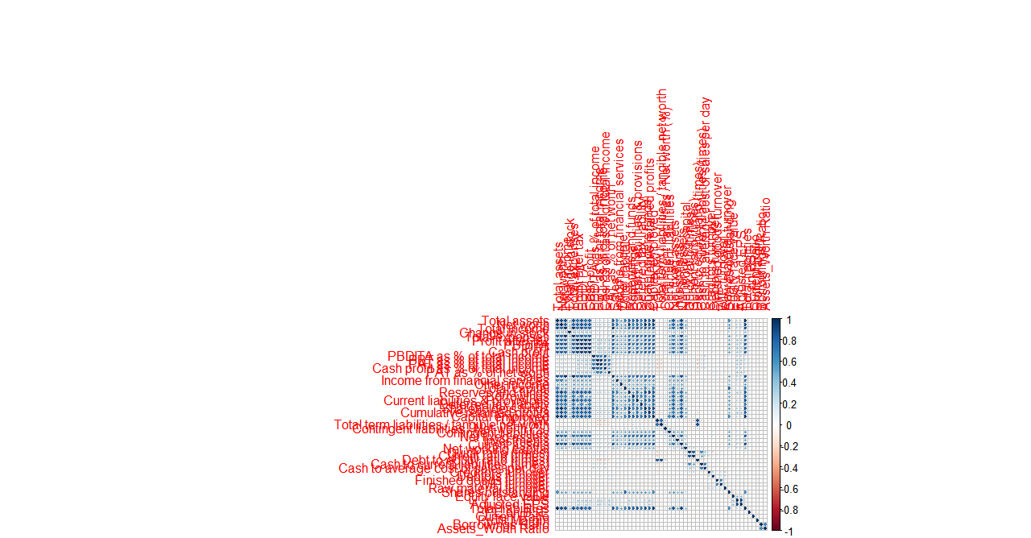

The blue dots in the plot,apart from the ones in diagonal indicates that multi collinearity exists in the dataset and so we have to use techniques like vif to remove them while doing Logistic regression.

Univariate Analysis - Histogram & Boxplot

From histogram, we get a distribution of values among the variables. From the beow plot we could see that apart from the below few variables, most of them do not have a normal distribution in place.

EBIDTA as a % of total income
EBT as a % of total income
Profit as a % of total income
Current ratio (times)
Quick ratio (times)
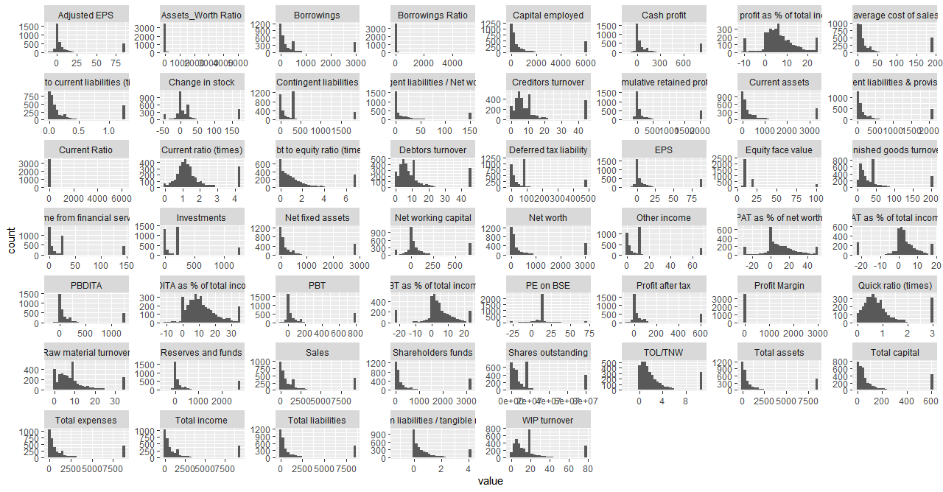

For boxplot we could not find many of the outliers as they have already been removed in the previous step during outlier treatment
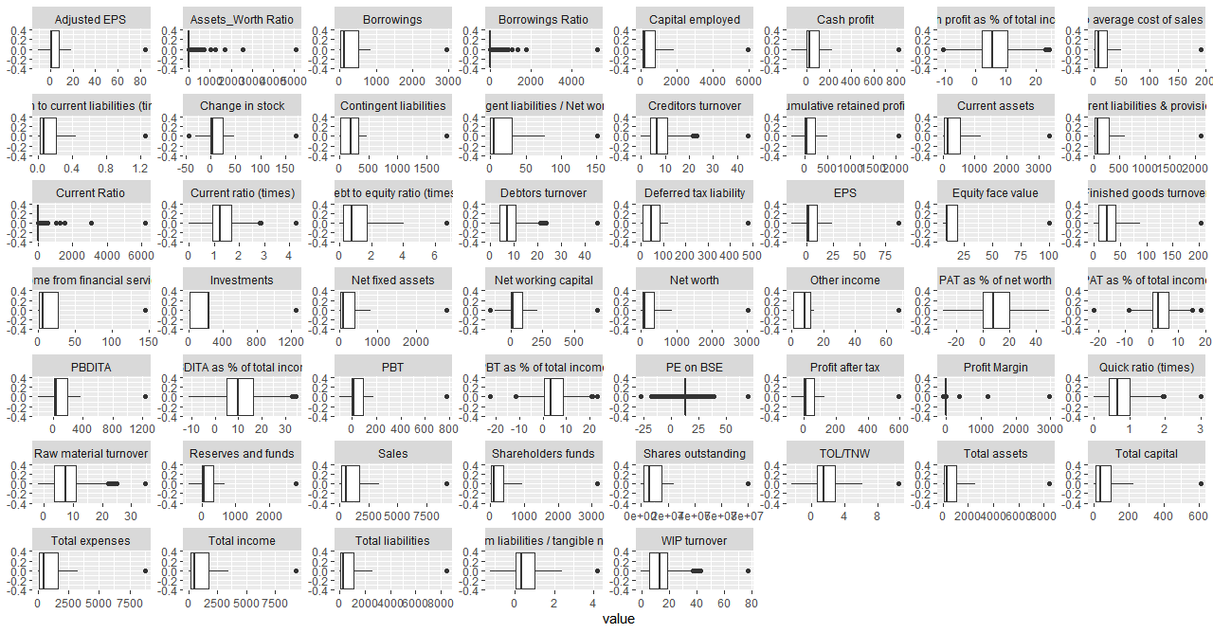

Bi-Variate Analysis

We will be doing bi-variate analysis on columns that we figured out as significant from Logistic Regression output. Below are those columns and we will be performing density plots on them.

Change in stock`,`Cash profit as % of total income`,`PAT as % of net worth`,
`Total capital`,`Cumulative retained profits`,`TOL/TNW`+`Contingent liabilities`,
Investments,`Current ratio (times)`,`Cash to current liabilities (times)`,`Adjusted EPS`,
`PE on BSE` , `Assets_Worth Ratio`

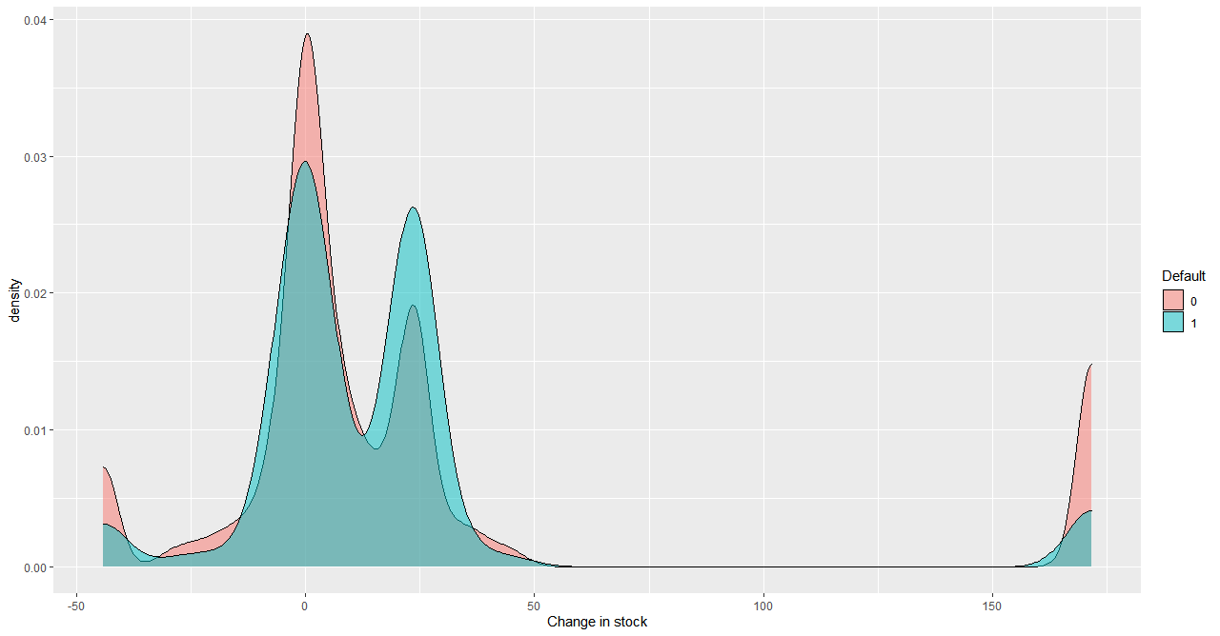

Observation: The change in stock variable does not distinctly vary for default/no-default behavior
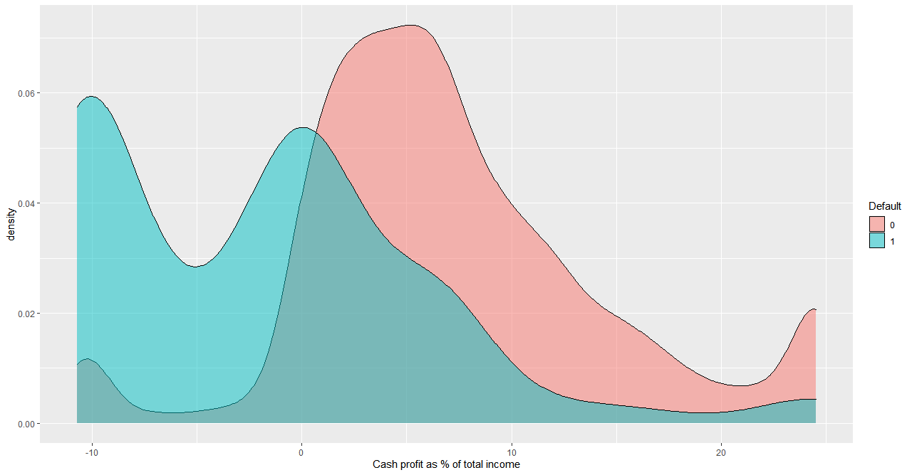
Observation: It seems that the corporations with low cash profit % of total income are likely to default more than high Cash profit companies.
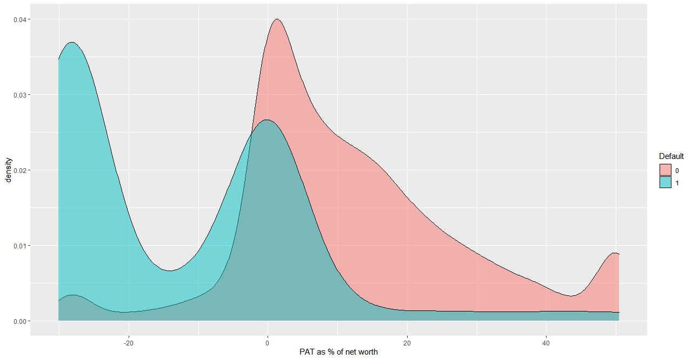
Observation: It seems that the corporations with low PAT as % of net worth are likely to default more than high PAT companies.

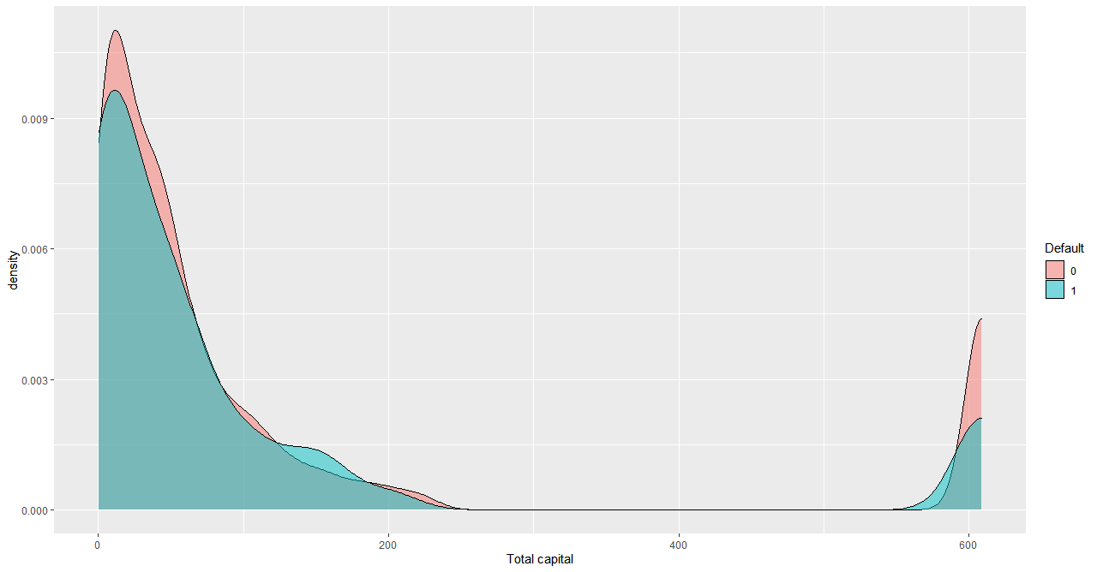
Observation: It seems that the Total Capaital does not vary distinctly b/w Default and non default companies.
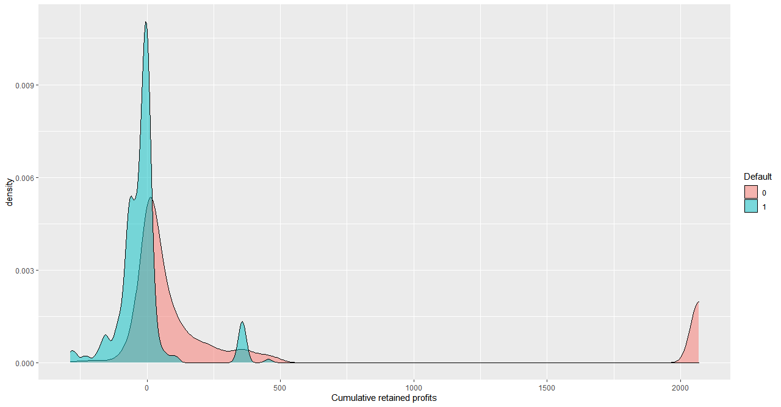
Observation: It seems that the corporations with low Cumulative retained profits are more likely to default more than high profit companies.

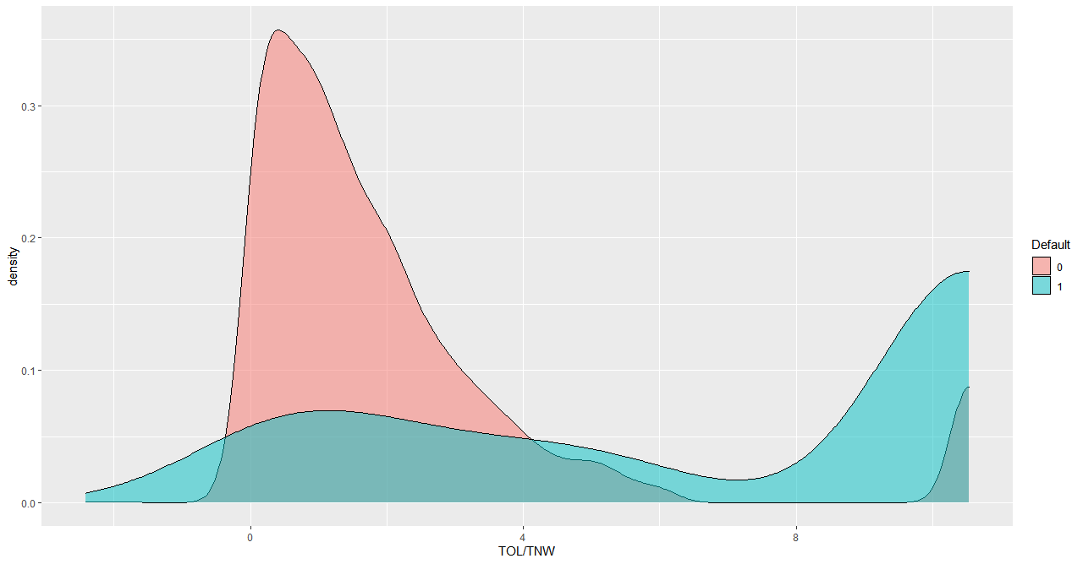
Observation: It seems that the corporations with high TOL/TNW are likely to default more than low TOL/TNW companies.

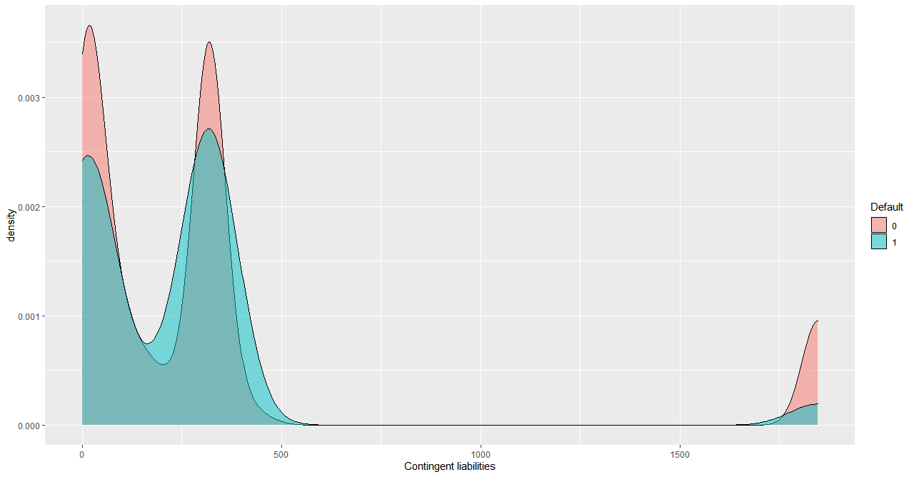
Observation: It seems that the variable Contingent liabilities does not vary distinctly b/w Default and non default companies.
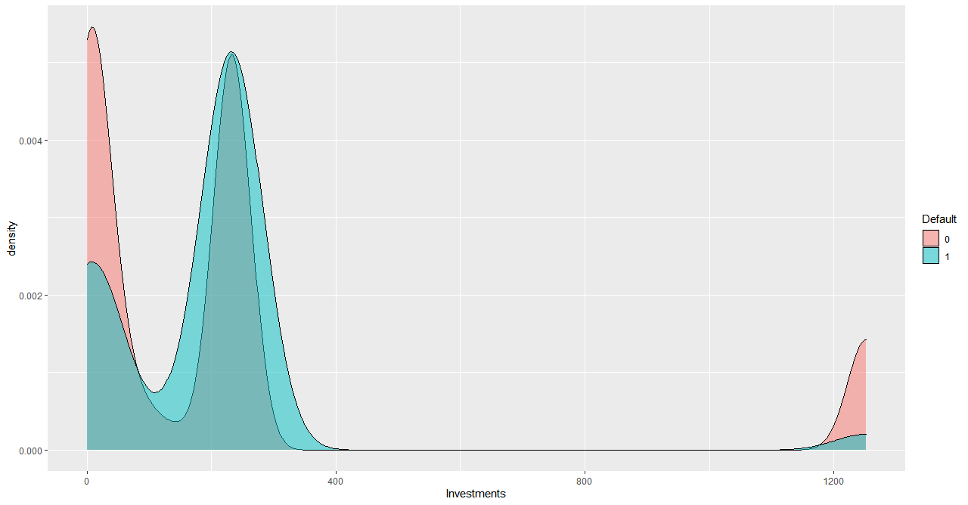
Observation: It seems that if the variable Investment does not vary distinctly b/w Default and non default companies.
.
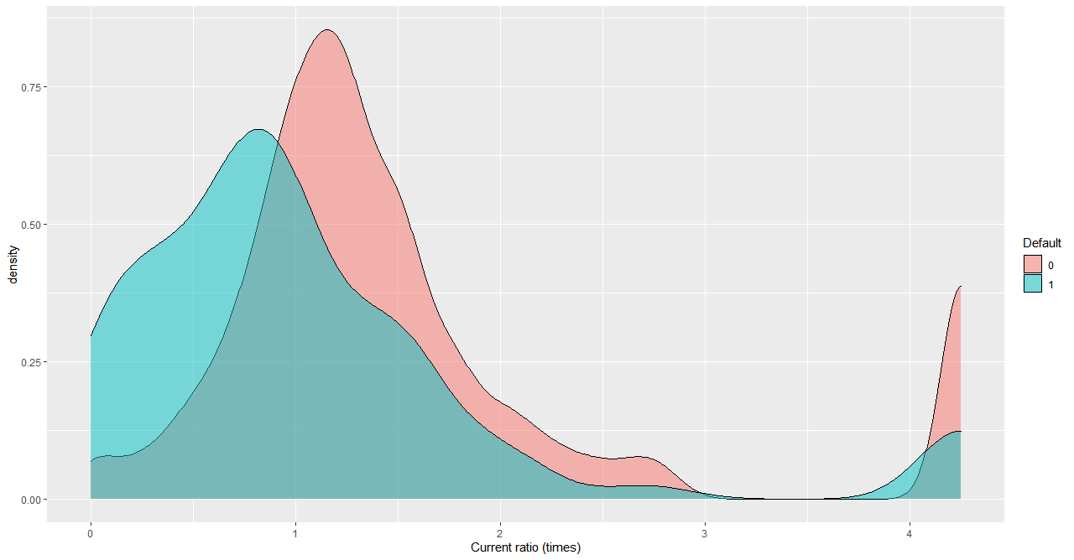
Observation: It seems that if the variable Current ratio (times) does not vary distinctly b/w Default and non default companies

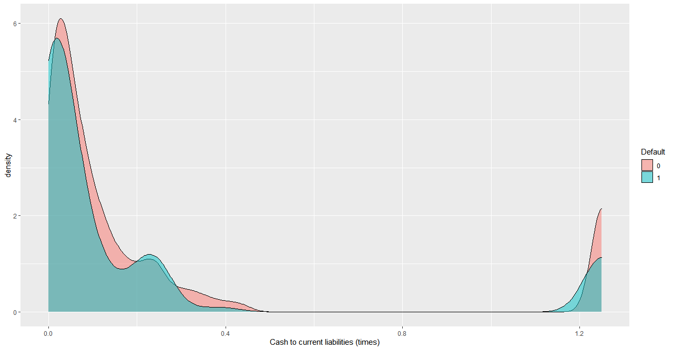

Observation: It seems that if the variable Cash to Current liabilities (times)does not vary distinctly b/w Default and non default companies

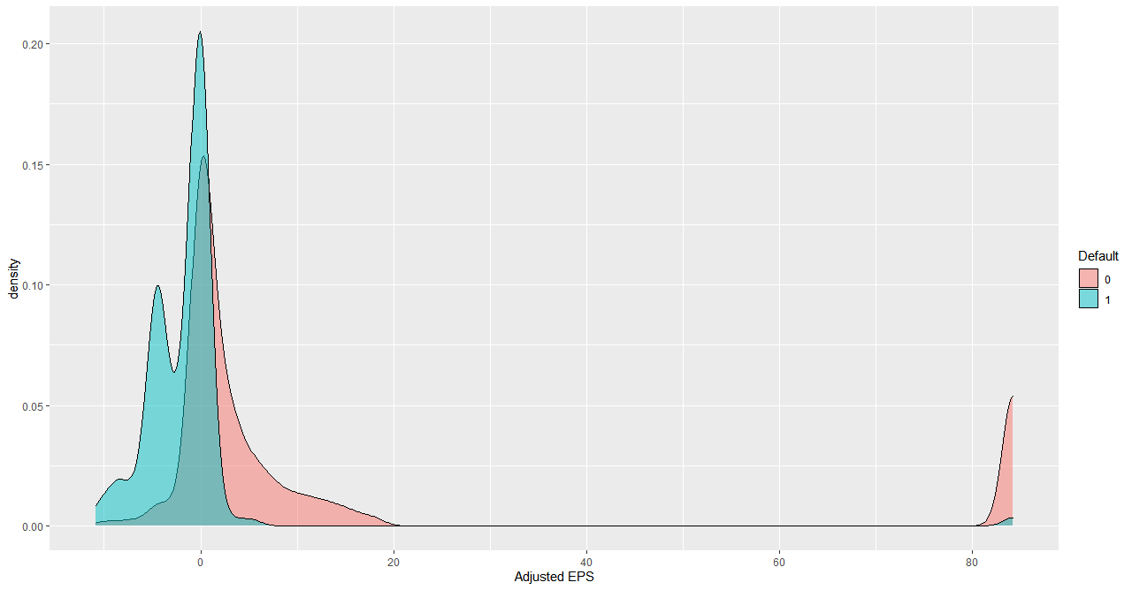
Observation: It seems that as the variable Adjusted EPS is more, the company is more likely to be defaulted. 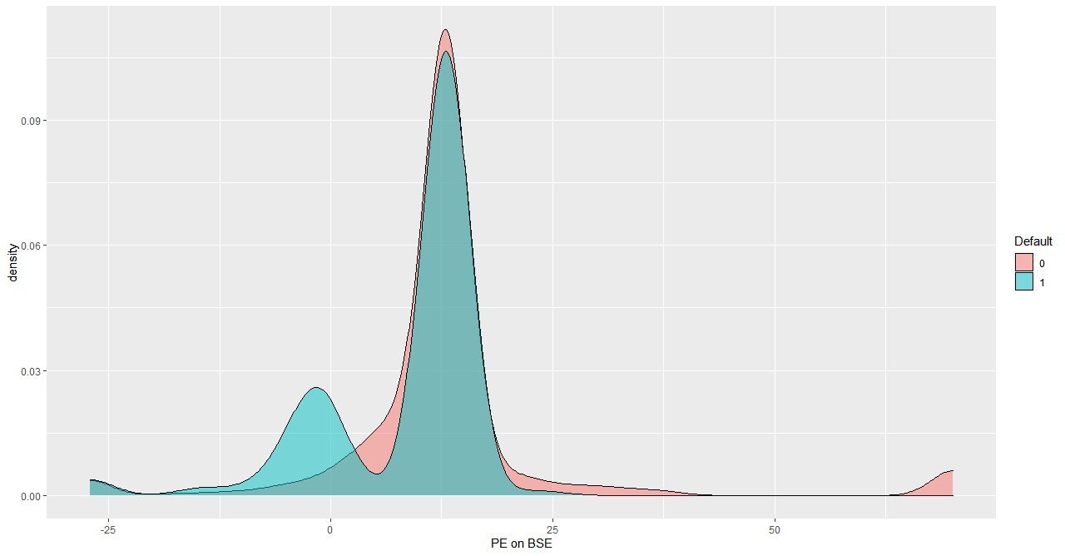
Observation: It seems that if the variable PE on BSE does not vary distinctly b/w Default and non default companies, but a higher value indicates that company is less likely to default.

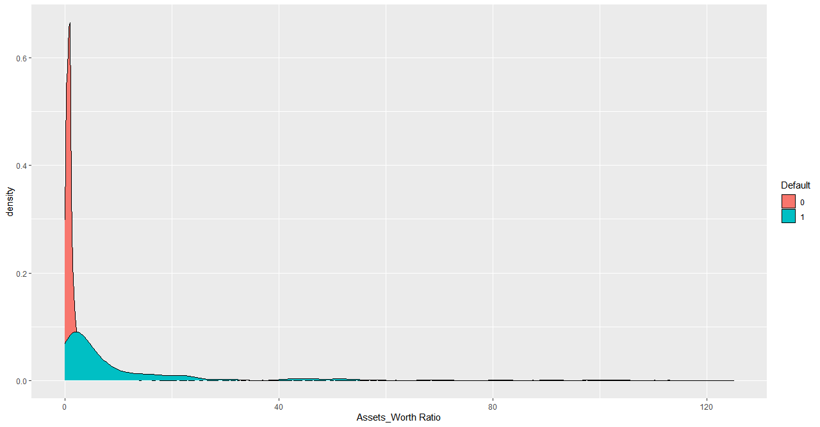

Observation: It seems that as the variable Assets_Worth ratio increases, the company is more likely to get defaulted.

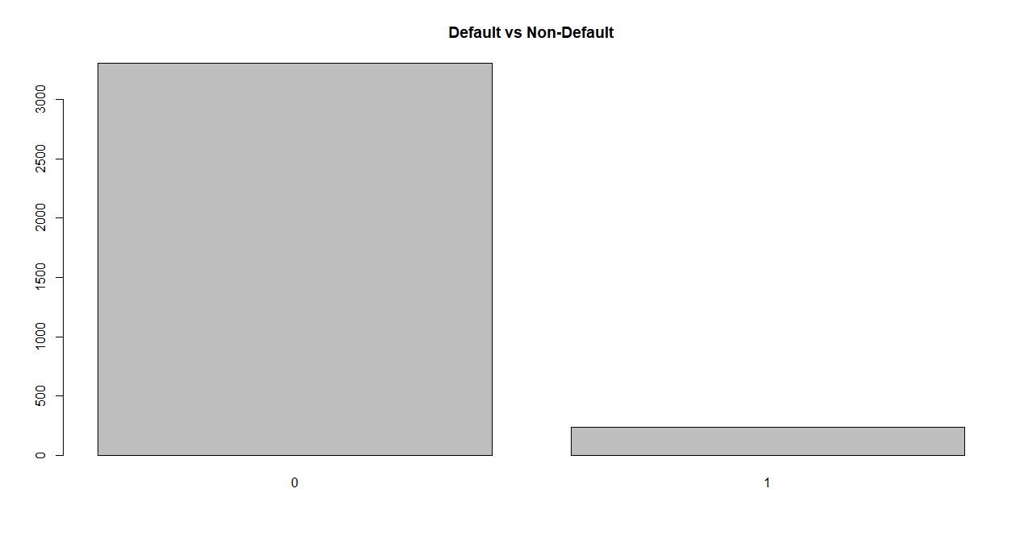

Build Logistic Regression Model on most important variables

Iteration1:
TrainModel=glm(Default~ .,data=data1,family = binomial)
summary(TrainModel)

Check Vif scores for the variables from LR output-

vif(TrainModel) `Total assets` `Net worth`
12.089448 6.472259
`Total income` `Change in stock`
21.608123 1.436768
`Total expenses` `Profit after tax`
20.270092 31.505725
PBDITA PBT
3.725048 31.946516
`Cash profit` `PBDITA as % of total income`
2.859205 2.233640
`PBT as % of total income` `PAT as % of total income`
16.865987 15.096353
`Cash profit as % of total income` `PAT as % of net worth`
3.868838 1.986684
Sales `Income from financial services`
12.258432 1.663692
`Other income` `Total capital`
1.594528 5.186695
`Reserves and funds` Borrowings
1.628493 4.923199
`Current liabilities & provisions` `Deferred tax liability`
5.327587 1.504896
`Shareholders funds` `Cumulative retained profits`
8.436646 2.309962
`Capital employed` `TOL/TNW`
11.923395 4.133991
`Total term liabilities / tangible net worth` `Contingent liabilities / Net worth (%)`
4.581199 1.344286
`Contingent liabilities` `Net fixed assets`
1.644264 4.527359
Investments `Current assets`
1.445424 7.827202
`Net working capital` `Quick ratio (times)`
1.906846 4.560071
`Current ratio (times)` `Debt to equity ratio (times)`
3.877089 5.646265
`Cash to current liabilities (times)` `Cash to average cost of sales per day`
2.576265 1.889836
`Creditors turnover` `Debtors turnover`
1.468385 1.459972
`Finished goods turnover` `WIP turnover`
2.014220 2.181370
`Raw material turnover` `Shares outstanding`
1.453294 3.163054
`Equity face value` EPS
1.156247 5.435401
`Adjusted EPS` `PE on BSE`
5.176186 1.169348
`Current Ratio` `Profit Margin`
1.145854 1.251024
`Borrowings Ratio` `Assets_Worth Ratio`
2.372984 3.030668

Variables with low vif values are-

`Change in stock`, PBDITA, `Cash profit`, `PBDITA as % of total income`,`Cash profit as % of total income`,
`PAT as % of net worth`, `Income from financial services`, `Other income`,
`Total capital`, `Reserves and funds` Borrowings, `Current liabilities & provisions`, `Deferred tax liability`,
`Cumulative retained profits`, `TOL/TNW`, `Total term liabilities / tangible net worth`,
`Contingent liabilities / Net worth (%)`, `Contingent liabilities`, `Net fixed assets` , Investments,
`Net working capital` ,`Quick ratio (times)`, `Current ratio (times)` , `Cash to current liabilities (times)` ,
`Cash to average cost of sales per day`,`Creditors turnover`, `Debtors turnover` , `Finished goods turnover`,
`WIP turnover`,`Raw material turnover` ,`Shares outstanding` , `Equity face value`,`Adjusted EPS`,`PE on BSE`
`Current Ratio`,`Profit Margin` , `Borrowings Ratio`,`Assets_Worth Ratio`

Iteration2:

We will do a new LR model with only those variables those have low vif scores.

TrainModel_2 = glm(Default~ `Change in stock`+PBDITA+`Cash profit`+`PBDITA as % of total income`++ `Cash profit as % of total income`+`PAT as % of net worth`+`Income from financial services`+`Other income`++ `Total capital`+`Reserves and funds`+Borrowings+`Current liabilities & provisions`+`Deferred tax liability`++ `Cumulative retained profits`+`TOL/TNW`+`Total term liabilities / tangible net worth`++ `Contingent liabilities / Net worth (%)`+`Contingent liabilities`+`Net fixed assets`+Investments++ `Net working capital`+`Quick ratio (times)`+`Current ratio (times)`+`Cash to current liabilities (times)`++ `Cash to average cost of sales per day`+`Creditors turnover`+`Debtors turnover`+`Finished goods turnover`++ `WIP turnover`+`Raw material turnover`+`Shares outstanding`+`Equity face value`+`Adjusted EPS`+`PE on BSE`+ + `Current Ratio`+`Profit Margin`+`Borrowings Ratio`+`Assets_Worth Ratio`,+ data=data1,family = binomial)

Coefficients:
Estimate Std. Error z value Pr(>|z|)
(Intercept) -2.793e+00 3.237e-01 -8.630 < 2e-16 ***
`Change in stock` 5.742e-03 2.450e-03 2.344 0.01907 *
PBDITA -3.785e-04 8.459e-04 -0.447 0.65457
`Cash profit` -6.669e-04 1.603e-03 -0.416 0.67737
`PBDITA as % of total income` -6.409e-03 1.466e-02 -0.437 0.66190
`Cash profit as % of total income` -5.284e-02 1.837e-02 -2.876 0.00403 **
`PAT as % of net worth` -3.936e-02 6.767e-03 -5.817 6.00e-09 ***
`Income from financial services` 5.783e-03 3.774e-03 1.532 0.12549
`Other income` 9.668e-03 8.396e-03 1.151 0.24953
`Total capital` -3.019e-03 1.116e-03 -2.705 0.00682 **
`Reserves and funds` -2.230e-04 3.262e-04 -0.684 0.49429
Borrowings 1.617e-04 2.268e-04 0.713 0.47578
`Current liabilities & provisions` -2.403e-04 3.098e-04 -0.776 0.43797
`Deferred tax liability` 1.301e-03 1.592e-03 0.817 0.41375
`Cumulative retained profits` -6.959e-03 1.561e-03 -4.458 8.27e-06 ***
`TOL/TNW` 2.073e-01 3.601e-02 5.757 8.59e-09 ***
`Total term liabilities / tangible net worth` 8.636e-02 8.784e-02 0.983 0.32554
`Contingent liabilities / Net worth (%)` 1.922e-03 1.775e-03 1.083 0.27891
`Contingent liabilities` -8.588e-04 3.475e-04 -2.471 0.01346 *
`Net fixed assets` -1.235e-04 2.740e-04 -0.451 0.65228
Investments 9.055e-04 4.676e-04 1.937 0.05280 .
`Net working capital` 1.720e-04 8.288e-04 0.207 0.83563
`Quick ratio (times)` -1.599e-01 2.795e-01 -0.572 0.56715
`Current ratio (times)` -3.572e-01 1.861e-01 -1.919 0.05496 .
`Cash to current liabilities (times)` 1.075e+00 3.689e-01 2.914 0.00357 **
`Cash to average cost of sales per day` 3.253e-04 1.786e-03 0.182 0.85552
`Creditors turnover` 6.529e-03 1.001e-02 0.652 0.51416
`Debtors turnover` -3.080e-03 8.733e-03 -0.353 0.72432
`Finished goods turnover` 1.379e-03 2.700e-03 0.511 0.60949
`WIP turnover` -6.879e-03 7.575e-03 -0.908 0.36382
`Raw material turnover` -1.878e-02 1.329e-02 -1.413 0.15762
`Shares outstanding` 1.132e-08 8.068e-09 1.403 0.16076
`Equity face value` 3.215e-03 4.234e-03 0.759 0.44760
`Adjusted EPS` -2.353e-02 1.354e-02 -1.737 0.08239 .
`PE on BSE` -1.392e-02 7.822e-03 -1.780 0.07505 .
`Current Ratio` 4.511e-05 1.484e-04 0.304 0.76117
`Profit Margin` 3.490e-03 3.556e-03 0.981 0.32650
`Borrowings Ratio` 2.670e-04 2.264e-04 1.179 0.23838
`Assets_Worth Ratio` 9.278e-04 2.102e-04 4.414 1.02e-05 ***
---
Signif. codes: 0 ‘***’ 0.001 ‘**’ 0.01 ‘*’ 0.05 ‘.’ 0.1 ‘ ’ 1

(Dispersion parameter for binomial family taken to be 1)

Null deviance: 1723.67 on 3540 degrees of freedom
Residual deviance: 892.64 on 3502 degrees of freedom
AIC: 970.64

Number of Fisher Scoring iterations: 10

Iteration3:

Removing Variables that are not significant and create a new LR model with the below significant variables. This will be our final model.

Most Important Variables-
`Change in stock`, `Cash profit as % of total income`, `PAT as % of net worth` , `Total capital` ,
`Cumulative retained profits` , `TOL/TNW` ,`Contingent liabilities` , Investments , `Current ratio (times)`
`Cash to current liabilities (times)` , `Adjusted EPS` , `PE on BSE` , `Assets_Worth Ratio`

TrainMode_3 = glm(Default~`Change in stock`+`Cash profit as % of total income`+`PAT as % of net worth`++ `Total capital`+`Cumulative retained profits`+`TOL/TNW`+`Contingent liabilities`++ Investments+`Current ratio (times)`+`Cash to current liabilities (times)`+`Adjusted EPS`++ `PE on BSE` + `Assets_Worth Ratio`,+ data=data1,family = binomial)

Coefficients:
Estimate Std. Error z value Pr(>|z|)
(Intercept) -2.6704063 0.2237078 -11.937 < 2e-16 ***
`Change in stock` 0.0052132 0.0021980 2.372 0.017705 *
`Cash profit as % of total income` -0.0570762 0.0138738 -4.114 3.89e-05 ***
`PAT as % of net worth` -0.0426925 0.0065241 -6.544 6.00e-11 ***
`Total capital` -0.0019585 0.0006257 -3.130 0.001748 **
`Cumulative retained profits` -0.0068566 0.0014292 -4.797 1.61e-06 ***
`TOL/TNW` 0.2346224 0.0221342 10.600 < 2e-16 ***
`Contingent liabilities` -0.0006414 0.0003020 -2.124 0.033665 *
Investments 0.0009831 0.0004203 2.339 0.019333 *
`Current ratio (times)` -0.4404630 0.1132399 -3.890 0.000100 ***
`Cash to current liabilities (times)` 1.0820297 0.2801624 3.862 0.000112 ***
`Adjusted EPS` -0.0246408 0.0140200 -1.758 0.078825 .
`PE on BSE` -0.0159777 0.0076702 -2.083 0.037243 *
`Assets_Worth Ratio` 0.0010925 0.0001607 6.797 1.07e-11 ***

---
Signif. codes: 0 ‘***’ 0.001 ‘**’ 0.01 ‘*’ 0.05 ‘.’ 0.1 ‘ ’ 1

(Dispersion parameter for binomial family taken to be 1)

Null deviance: 1723.67 on 3540 degrees of freedom
Residual deviance: 914.76 on 3527 degrees of freedom
AIC: 942.76

Number of Fisher Scoring iterations: 10

Vif o/p of final train model -

vif(TrainModel_3) `Change in stock` `Cash profit as % of total income` `PAT as % of net worth`
1.128959 1.365935 1.552989
`Total capital` `Cumulative retained profits` `TOL/TNW`
1.495174 1.830112 1.159112
`Contingent liabilities` Investments `Current ratio (times)`
1.161534 1.153232 1.451645
`Cash to current liabilities (times)` `Adjusted EPS` `PE on BSE`
1.497696 1.150290 1.070051
`Assets_Worth Ratio`
1.472730

Analyze LR coefficients and their signs

Negative coefficient Variables:

Below are the negative coefficient variables from our analysis.
Cash profit as % of total income
PAT as % of net worth
Total capital
Cumulative retained profits
Contingent liabilities
Current ratio (times)
Adjusted EPS
PE on BSE

Interpretation: Since the above coefficients are negative, the probability of default(1) decreases as their magnitude increases assuming all other factors remain the same. So we can say that as the above variable values increases, it is more likely that our company will not default and so we would ideally want their magnitude on the higher side.

2)Positive coefficient Variables:

Below are the positive coefficient variables from our analysis.
Change in stock
`TOL/TNW`
Investments
`Cash to current liabilities (times)`
`Assets_Worth Ratio`

Interpretation: Since the above coefficients are positive, the probability of default(1) also increases as their magnitude increases assuming all other factors remain the same. So we can say that as the above variable values increases, it is more likely that our company will be defaulted and so we would ideally want their magnitude to be on the lower side.

Model Performance Measures

Checking the distribution of Default Vs Non-Default in Train dataset
> #Checking the train dataset distribution of Default & Non-default> summary(data1$Default) 0 1
3307 234

Predict accuracy of model on dev dataset

Making predictions for the train dataset-

Performance Metric Charts-

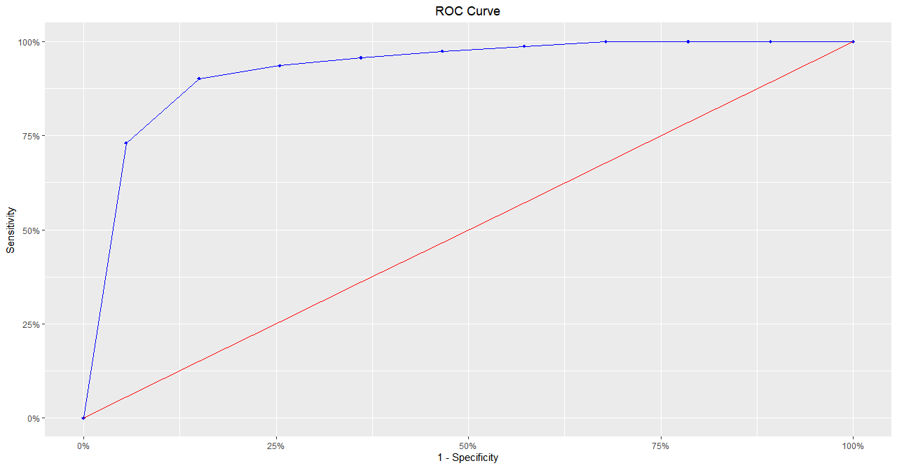

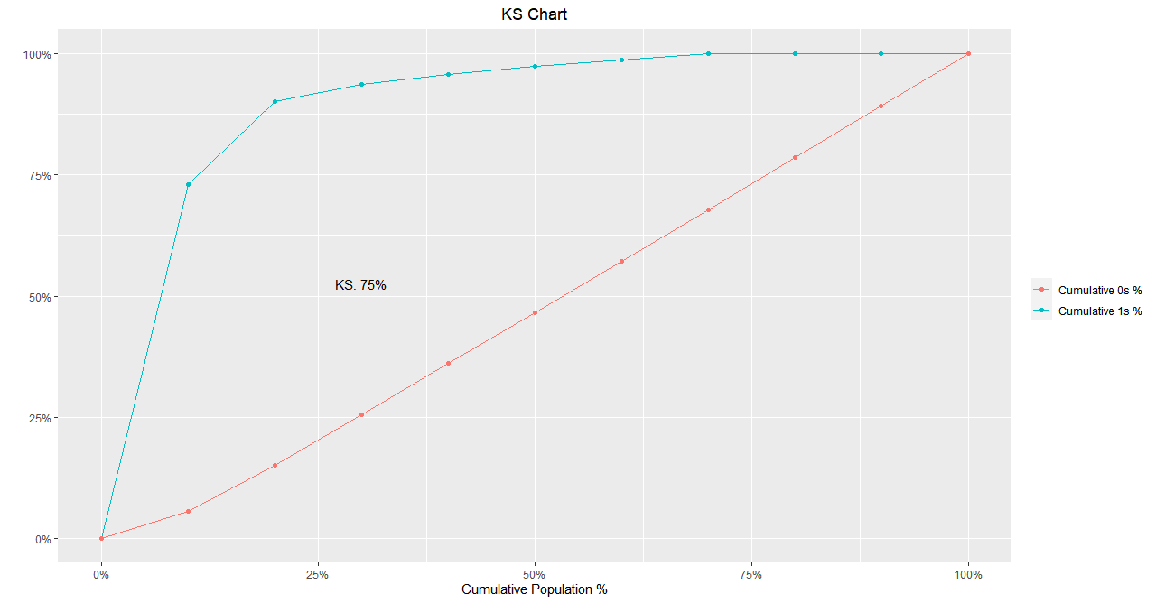

Confusion Matrix and Statistics

Reference
Prediction 0 1
0 3269 120
1 38 114

Accuracy : 0.9554
No Information Rate : 0.9339

Kappa : 0.5682

McNemars's Test P-Value : 0.0000

Sensitivity : 0.4872
Specificity : 0.9885
Pos Pred Value : 0.7500
Neg Pred Value : 0.9646
Prevalence : 0.0661
Detection Rate : 0.0322
Detection Prevalence : 0.0429
Balanced Accuracy : 0.7378
Precision : 0.7500
Recall : 0.4872

'Positive' Class : 1

Train dataset snapshot-
#Accuracy = (3269+114)/(3269+120+38+114) = 95.5%
#Sensitivity = (114)/(120+114)=48.7%
#Specificity = (3269)/(3269+38) = 98.8%

KS - Score = 0.76

> pred_ratio_train <- prediction(data1$PredScore, data1$Default)> perf_ratio_train <- performance(pred_ratio_train, "tpr", "fpr")
> plot(perf_ratio_train,main = "ROC curve")
> KS_train = max(perf_ratio_train@y.values[[1]]-perf_ratio_train@x.values[[1]])
> KS_train[1] 0.7626105

AUC - Score = 0.94
> ROCRpred = prediction(pred_train, data1$Default)
> as.numeric(performance(ROCRpred, "auc")@y.values)
[1] 0.9391423

Gini- Score = 0.81
> blr_gini_index(TrainModel_3, data = data1)
[1] 0.8130735

Predict accuracy of model on validation dataset

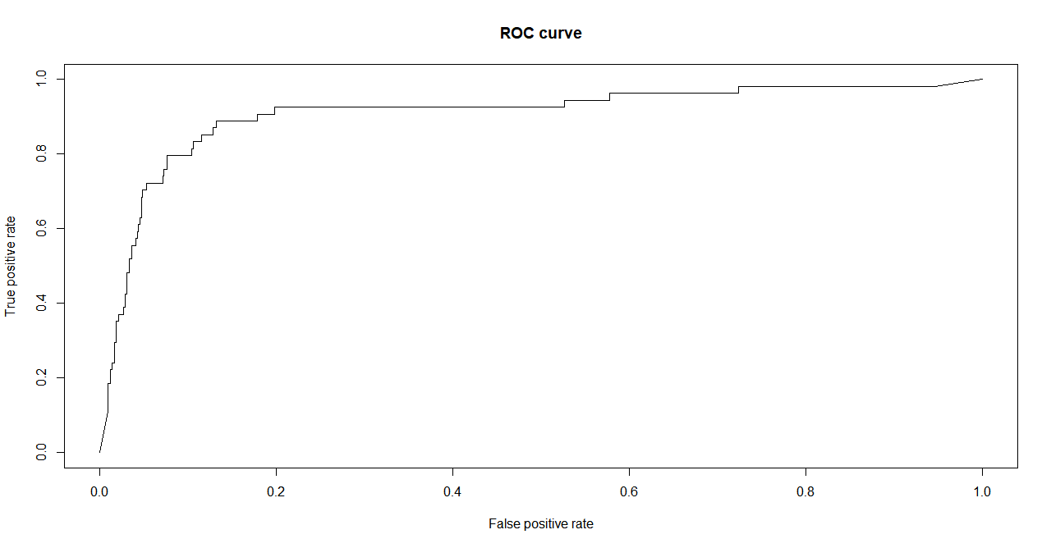
Test dataset snapshot-

> #Confusion Matrix> table(data_test$PredClass, data_test$`Default - 1`)
0 1
0 625 15
1 36 39

#Accuracy = (625+39)/(625+15+36+39) = 92.8%
#Sensitivity = (39)/(39+15)=72.2%
#Specificity = (625)/(625+36) = 94.5%

KS - Score = 0.75
KS_test = max(perf_ratio_test@y.values[[1]]-perf_ratio_test@x.values[[1]])
>
KS_test[1] 0.7572701

AUC-Score = 0.90
> auc_test = performance(pred_ratio_test,"auc");
> auc_test = as.numeric(auc_test@y.values)
> auc_test[1] 0.9071553

Gini-Score = 0.89
> ##Gini Score> gini_test = ineq(data_test$PredClass, type="Gini")> gini_test[1] 0.8951049

Observations:
For the train data we got an accuracy of around 95%, Specificity of 98% but sensitivity was only around 49%. However for validation dataset, we could see that even though accuracy was only around 93% and specificity of 95%, the Specificity greatly improved to 72% which is good because it helps us in better predicting the default scenarios.

Also the other model performance Indicators like AUC, KS & Gini were having a value for test dataset almost comparable to that in train dataset.

Sort the data in descending order based on probability of default and then divide into 10 dociles based on probability & check how well the model has performed

> #Creating a decile> library(dplyr)> data_decile = mutate(data_test, decile_rank = ntile(desc(data_test$PredScore),10))

> table(data_decile[, c(1, 16, 17)][data_decile$decile_rank == 1,]), , decile_rank = 1

PredClass
Default - 1 1
0 34
1 38
> table(data_decile[, c(1, 16, 17)][data_decile$decile_rank == 2,]), , decile_rank = 2

PredClass
Default - 1 0 1
0 60 2
1 9 1
> table(data_decile[, c(1, 16, 17)][data_decile$decile_rank == 3,]), , decile_rank = 3

PredClass
Default - 1 0
0 70
1 2
> table(data_decile[, c(1, 16, 17)][data_decile$decile_rank == 4,]), , decile_rank = 4

PredClass
Default - 1 0
0 72
1 0
> table(data_decile[, c(1, 16, 17)][data_decile$decile_rank == 5,]), , decile_rank = 5

PredClass
Default - 1 0
0 72
1 0
> table(data_decile[, c(1, 16, 17)][data_decile$decile_rank == 6,]), , decile_rank = 6

PredClass
Default - 1 0
0 70
1 1
> table(data_decile[, c(1, 16, 17)][data_decile$decile_rank == 7,]), , decile_rank = 7

PredClass
Default - 1 0
0 70
1 1
> table(data_decile[, c(1, 16, 17)][data_decile$decile_rank == 8,]), , decile_rank = 8

PredClass
Default - 1 0
0 70
1 1
> table(data_decile[, c(1, 16, 17)][data_decile$decile_rank == 9,]), , decile_rank = 9

PredClass
Default - 1 0
0 71
1 0
> table(data_decile[, c(1, 16, 17)][data_decile$decile_rank == 10,]), , decile_rank = 10

PredClass
Default - 1 0
0 70
1 1

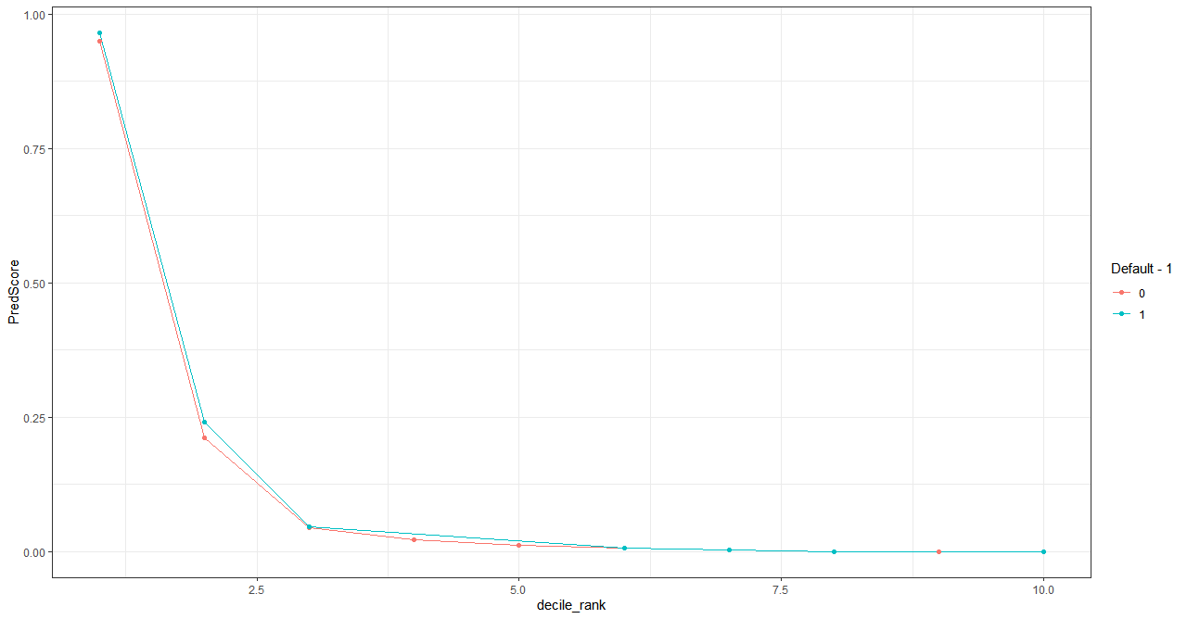

Rank 1 Accuracy = 52%
Rank 2 Accuracy = 84.7%
Rank 3 Accuracy = 95.9%
Rank 4 Accuracy = 98.6%
Rank 5 Accuracy = 98.6%
Rank 6 Accuracy = 97.2%
Rank 7 Accuracy = 97.2%
Rank 8 Accuracy = 97.2%
Rank 9 Accuracy = 98.6%
Rank 10 Accuracy =98.6%

Conclusion:
We started by importing the train dataset. We did the treatment to change the variable class name accordingly. After which as a part of EDA, we did outlier treatment and missing value treatment. Then we checked for multi collinearity and found out that it exists in the dataset.Then we started building a logistic model by selecting variables. In the process using VIF and significance of variables, we arrived at the most important variables and then built a final model using those variables.

Once the model was built, we checked for model performance using the performance metrics and confusion metric parameters such as Accuracy and Sensitivity/Recall for the train data. After that the validation data was taken and predictions were made using the model created from previous step. The model performance for test data was also checked and verified that results are satisfactory.

Finally we created a decile after arranging the predicted probability in the descending order and created a decile chart. From the decile, we observed that the rank 1 customer-who has the highest probability of being a default had only an accuracy of only 52%, but the accuracy of all other ranks were much higher (> 80%). So this model even though accuracy is low for Rank 1 customers, it gives us some buffer that we don’t end up providing the loan to a customer who might end up as a defaulter.

Appendix
##########################################
############India Credit Default##########
##########################################

library(ggplot2)
library(readxl)
library(car)
library(corrplot)
library(caTools)
library(ROCR)
library(ineq)
library(caret)
library(blorr)

getwd()
setwd("C:/2020/Finance_Risk_Analytics/Assignment")
# Import the Train dataset, we will convert empty cells as NA while importing
data1 <- read_excel("raw-data.xlsx")
View(data1)
str(data1)
dim(data1)
head(data1)
tail(data1)
names(data1)
#Change NA to resembele blank-NA
data1[data1=="NA"] <- NA
sapply(data1, function(x) {sum(is.na(x))})

str(data1)

# Remove Deposits as it is empty and Num columns as it is just serial numbers
data1 <- data1[c(-1,-22)]

# Convert the below 8 character variables to numeric
#Creditors turnover, Debtors turnover, Finished goods turnover, WIP turnover, Raw material turnover ,
#Shares outstanding,Equity face value, PE on BSE
data1$`Creditors turnover`<- as.numeric(data1$`Creditors turnover`)
data1$`Debtors turnover` <- as.numeric(data1$`Debtors turnover`)
data1$`Finished goods turnover`<- as.numeric(data1$`Finished goods turnover`)
data1$`WIP turnover` <- as.numeric(data1$`WIP turnover`)
data1$`Raw material turnover`<- as.numeric(data1$`Raw material turnover`)
data1$`Shares outstanding` <- as.numeric(data1$`Shares outstanding`)
data1$`Equity face value`<- as.numeric(data1$`Equity face value`)
data1$`PE on BSE`<- as.numeric(data1$`PE on BSE`)

#Checking the structure of variables again
str(data1)

#Creating the Target variable from Networth Next Year
data1$Default <- ifelse(data1$`Networth Next Year` >= 0, 0, 1)
data1$Default<- as.factor(data1$Default)
View(data1)
names(data1)

#Check data summary
attach(data1)
summary(data1)
#Checking for Outliers
boxplot(data1)
sapply(data1[c(-1,-51)], function(x) {length(boxplot.stats(x)$out)})

# Perform Outlier Treatment
# Outlier function

Outlier <- function(x){
qnt <- quantile(x, probs=c(.25, .75), na.rm = T)
caps <- quantile(x, probs=c(.05, .95), na.rm = T)
H <- 1.5 * IQR(x, na.rm = T)
x[x < (qnt[1] - H)] <- caps[1]
x[x > (qnt[2] + H)] <- caps[2]
return(x)
}

# Apply Outlier functions to all columns
data1$`Total assets` <- Outlier(data1$`Total assets`)
data1$`Net worth` <- Outlier(data1$`Net worth`)
data1$`Total income`<- Outlier(data1$`Total income`)
data1$`Change in stock`<- Outlier(data1$`Change in stock`)
data1$`Total expenses`<- Outlier(data1$`Total expenses`)
data1$`Profit after tax`<- Outlier(data1$`Profit after tax`)
data1$PBDITA<- Outlier(data1$PBDITA)
data1$PBT<- Outlier(data1$PBT)
data1$`Cash profit`<- Outlier(data1$`Cash profit`)
data1$`PBDITA as % of total income`<- Outlier(data1$`PBDITA as % of total income`)
data1$`PBT as % of total income`<- Outlier(data1$`PBT as % of total income`)
data1$`PAT as % of total income`<- Outlier(data1$`PAT as % of total income`)
data1$`Cash profit as % of total income`<- Outlier(data1$`Cash profit as % of total income`)
data1$`PAT as % of net worth`<- Outlier(data1$`PAT as % of net worth`)
data1$Sales<- Outlier(data1$Sales)
data1$`Income from financial services`<- Outlier(data1$`Income from financial services`)
data1$`Other income`<- Outlier(data1$`Other income`)
data1$`Total capital`<- Outlier(data1$`Total capital`)
data1$`Reserves and funds`<- Outlier(data1$`Reserves and funds`)
data1$Borrowings<- Outlier(data1$Borrowings)
data1$`Current liabilities & provisions`<- Outlier(data1$`Current liabilities & provisions`)
data1$`Deferred tax liability`<- Outlier(data1$`Deferred tax liability`)
data1$`Shareholders funds`<- Outlier(data1$`Shareholders funds`)
data1$`Cumulative retained profits`<- Outlier(data1$`Cumulative retained profits`)
data1$`Capital employed`<- Outlier(data1$`Capital employed`)
data1$`TOL/TNW`<- Outlier(data1$`TOL/TNW`)
data1$`Total term liabilities / tangible net worth`<- Outlier(data1$`Total term liabilities / tangible net worth`)
data1$`Contingent liabilities / Net worth (%)`<- Outlier(data1$`Contingent liabilities / Net worth (%)`)
data1$`Contingent liabilities`<- Outlier(data1$`Contingent liabilities`)
data1$`Net fixed assets`<- Outlier(data1$`Net fixed assets`)
data1$Investments<- Outlier(data1$Investments)
data1$`Current assets`<- Outlier(data1$`Current assets`)
data1$`Net working capital`<- Outlier(data1$`Net working capital`)
data1$`Quick ratio (times)`<- Outlier(data1$`Quick ratio (times)`)
data1$`Current ratio (times)`<- Outlier(data1$`Current ratio (times)`)
data1$`Debt to equity ratio (times)`<- Outlier(data1$`Debt to equity ratio (times)`)
data1$`Cash to current liabilities (times)`<- Outlier(data1$`Cash to current liabilities (times)`)
data1$`Cash to average cost of sales per day`<- Outlier(data1$`Cash to average cost of sales per day`)
data1$`Creditors turnover`<- Outlier(data1$`Creditors turnover`)
data1$`Debtors turnover`<- Outlier(data1$`Debtors turnover`)
data1$`Finished goods turnover`<- Outlier(data1$`Finished goods turnover`)
data1$`WIP turnover`<- Outlier(data1$`WIP turnover`)
data1$`Raw material turnover`<- Outlier(data1$`Raw material turnover`)
data1$`Shares outstanding`<- Outlier(data1$`Shares outstanding`)
data1$`Equity face value`<- Outlier(data1$`Equity face value`)
data1$`EPS`<- Outlier(data1$`EPS`)
data1$`Adjusted EPS`<- Outlier(data1$`Adjusted EPS`)
data1$`Total liabilities`<- Outlier(data1$`Total liabilities`)
data1$`PE on BSE`<- Outlier(data1$`PE on BSE`)
#######################################################

boxplot.stats(data1$`Change in stock`)$out
boxplot(data1$`Change in stock`)
boxplot(data1$`PE on BSE`)

##########################################################
#Remove Next Worth Next Year Column
data1 <- data1[-1]
names(data1)

#Perform Missing Value Treatment
#Check for Missing Values (NA)
sapply(data1,function(x) sum(is.na(x)))

# Creating a for loop to change all NA values to the mean value of that column
# for(i in 1:49)
# {
# data1[is.na(data1[,i]), i] <- mean(data1[,i], na.rm = TRUE)
# }

#Missing Value treatment by changing NA to mean of the data
data1$`Change in stock`[which(is.na(data1$`Change in stock`))] <- mean(data1$`Change in stock`,na.rm=T)
data1$`Total income`[which(is.na(data1$`Total income`))] <- mean(data1$`Total income`,na.rm=T)

data1$`Change in stock`[which(is.na(data1$`Change in stock`))] <- mean(data1$`Change in stock`,na.rm=T)

data1$`Total expenses`[which(is.na(data1$`Total expenses`))] <- mean(data1$`Total expenses`,na.rm=T)

data1$`Profit after tax`[which(is.na(data1$`Profit after tax`))] <- mean(data1$`Profit after tax`,na.rm=T)

data1$PBDITA[which(is.na(data1$PBDITA))] <- mean(data1$PBDITA,na.rm=T)

data1$PBT[which(is.na(data1$PBT))] <- mean(data1$PBT,na.rm=T)

data1$`Cash profit`[which(is.na(data1$`Cash profit`))] <- mean(data1$`Cash profit`,na.rm=T)

data1$`PBDITA as % of total income`[which(is.na(data1$`PBDITA as % of total income`))] <- mean(data1$`PBDITA as % of total income`,na.rm=T)

data1$`PBT as % of total income`[which(is.na(data1$`PBT as % of total income`))] <- mean(data1$`PBT as % of total income`,na.rm=T)

data1$`PAT as % of total income`[which(is.na(data1$`PAT as % of total income`))] <- mean(data1$`PAT as % of total income`,na.rm=T)

data1$`Cash profit as % of total income`[which(is.na(data1$`Cash profit as % of total income`))] <- mean(data1$`Cash profit as % of total income`,na.rm=T)

data1$Sales[which(is.na(data1$Sales))] <- mean(data1$Sales,na.rm=T)

data1$`Income from financial services`[which(is.na(data1$`Income from financial services`))] <- mean(data1$`Income from financial services`,na.rm=T)

data1$`Other income`[which(is.na(data1$`Other income`))] <- mean(data1$`Other income`,na.rm=T)

data1$`Total capital`[which(is.na(data1$`Total capital`))] <- mean(data1$`Total capital`,na.rm=T)

data1$`Reserves and funds`[which(is.na(data1$`Reserves and funds`))] <- mean(data1$`Reserves and funds`,na.rm=T)

data1$Borrowings[which(is.na(data1$Borrowings))] <- mean(data1$Borrowings,na.rm=T)

data1$`Current liabilities & provisions`[which(is.na(data1$`Current liabilities & provisions`))] <- mean(data1$`Current liabilities & provisions`,na.rm=T)

data1$`Deferred tax liability`[which(is.na(data1$`Deferred tax liability`))] <- mean(data1$`Deferred tax liability`,na.rm=T)

data1$`Cumulative retained profits`[which(is.na(data1$`Cumulative retained profits`))] <- mean(data1$`Cumulative retained profits`,na.rm=T)

data1$`Contingent liabilities`[which(is.na(data1$`Contingent liabilities`))] <- mean(data1$`Contingent liabilities`,na.rm=T)

data1$`Net fixed assets`[which(is.na(data1$`Net fixed assets`))] <- mean(data1$`Net fixed assets`,na.rm=T)

data1$Investments[which(is.na(data1$Investments))] <- mean(data1$Investments,na.rm=T)

data1$`Current assets`[which(is.na(data1$`Current assets`))] <- mean(data1$`Current assets`,na.rm=T)

data1$`Net working capital`[which(is.na(data1$`Net working capital`))] <- mean(data1$`Net working capital`,na.rm=T)

data1$`Quick ratio (times)`[which(is.na(data1$`Quick ratio (times)`))] <- mean(data1$`Quick ratio (times)`,na.rm=T)

data1$`Current ratio (times)`[which(is.na(data1$`Current ratio (times)`))] <- mean(data1$`Current ratio (times)`,na.rm=T)

data1$`Cash to current liabilities (times)`[which(is.na(data1$`Cash to current liabilities (times)`))] <- mean(data1$`Cash to current liabilities (times)`,na.rm=T)

data1$`Cash to average cost of sales per day`[which(is.na(data1$`Cash to average cost of sales per day`))] <- mean(data1$`Cash to average cost of sales per day`,na.rm=T)

data1$`Creditors turnover`[which(is.na(data1$`Creditors turnover`))] <- mean(data1$`Creditors turnover`,na.rm=T)

data1$`Debtors turnover`[which(is.na(data1$`Debtors turnover`))] <- mean(data1$`Debtors turnover`,na.rm=T)

data1$`Finished goods turnover`[which(is.na(data1$`Finished goods turnover`))] <- mean(data1$`Finished goods turnover`,na.rm=T)

data1$`WIP turnover`[which(is.na(data1$`WIP turnover`))] <- mean(data1$`WIP turnover`,na.rm=T)

data1$`Raw material turnover`[which(is.na(data1$`Raw material turnover`))] <- mean(data1$`Raw material turnover`,na.rm=T)

data1$`Equity face value`[which(is.na(data1$`Equity face value`))] <- mean(data1$`Equity face value`,na.rm=T)

data1$`Adjusted EPS`[which(is.na(data1$`Adjusted EPS`))] <- mean(data1$`Adjusted EPS`,na.rm=T)

data1$`PE on BSE`[which(is.na(data1$`PE on BSE`))] <- mean(data1$`PE on BSE`,na.rm=T)

data1$`Shares outstanding`[which(is.na(data1$`Shares outstanding`))] <- mean(data1$`Shares outstanding`,na.rm=T)
#Check again for Missing values
sapply(data1,function(x) sum(is.na(x)))

#New Variables Creation (One ration for profitability, leverage, liquidity and company's size each )

#Liquidity - Current Ratio = Current Assets/Current Liabilities
data1$`Current Ratio` = data1$`Current assets`/data1$`Current liabilities & provisions`

#Profitability - Profit Margin = Profit after tax /sales
data1$`Profit Margin` = data1$`Profit after tax`/data1$Sales

#Leverage - Borrowings Ratio = Borrowings/Total Liabilities
data1$`Borrowings Ratio` = data1$Borrowings/data1$`Total liabilities`

#Company Size - Net Fixed Assets to Net worth ratio = Fixed Assets/Net Worth
data1$`Assets_Worth Ratio` = data1$`Net fixed assets`/data1$`Net worth`

#Converting Asset Worth Ratio of values -zero & Inf to the median value of the group
data1$`Assets_Worth Ratio`[data1$`Assets_Worth Ratio`==0] <- median(data1$`Assets_Worth Ratio`)
data1$`Assets_Worth Ratio`[data1$`Assets_Worth Ratio`==Inf] <- median(data1$`Assets_Worth Ratio`)

sum(is.nan(data1$`Assets_Worth Ratio`))
names(data1)
head(data1)
str(data1)

#Check for multicollinearity
cor(data1[,-c(50)])
corrplot(cor(data1[,-c(50)]))
#correlation=corrplot(cor(train[,-c(1,3)]),method = "circle",type = "upper")
corrplot(cor(data1[,-c(50)]),method = "circle",type = "upper")

# data1$`Assets_Worth Ratio`[data1$`Assets_Worth Ratio`==0]
# min(data1$`Assets_Worth Ratio`)

#Uni-Variate Analysis
#####################################
library(purrr)
library(tidyr)
library(ggplot2)

#Histogram
data1 %>%
keep(is.numeric) %>%
gather() %>%
ggplot(aes(value)) +
facet_wrap(~ key, scales = "free") +
geom_histogram()
####################################
#Boxplot
data %>%
keep(is.numeric) %>%
gather() %>%
ggplot(aes(value)) +
facet_wrap(~ key, scales = "free") +
geom_boxplot()
###################################
## Bi-Variate
#Below are the significant variables that we got from LR o/p for which we will be doing bi-variate analysis

#Change in stock`,`Cash profit as % of total income`,`PAT as % of net worth`,
#`Total capital`,`Cumulative retained profits`,`TOL/TNW`+`Contingent liabilities`,
#Investments,`Current ratio (times)`,`Cash to current liabilities (times)`,`Adjusted EPS`,
#`PE on BSE` , `Assets_Worth Ratio`

#ggplot(data2, aes(x=Default), y=(data2$`Shares outstanding`)))
#geom_bar(stat="identity", width=0.5)

ggplot(data1, aes(`Change in stock`, fill= Default)) + geom_density(alpha=0.5)
ggplot(data1, aes(`Cash profit as % of total income`, fill= Default)) + geom_density(alpha=0.5)
ggplot(data1, aes(`PAT as % of net worth`, fill= Default)) + geom_density(alpha=0.5)
ggplot(data1, aes(`Total capital`, fill= Default)) + geom_density(alpha=0.5)
ggplot(data1, aes(`Cumulative retained profits`, fill= Default)) + geom_density(alpha=0.5)
ggplot(data1, aes(`TOL/TNW`, fill= Default)) + geom_density(alpha=0.5)
ggplot(data1, aes(`Contingent liabilities`, fill= Default)) + geom_density(alpha=0.5)
ggplot(data1, aes(`Investments`, fill= Default)) + geom_density(alpha=0.5)
ggplot(data1, aes(`Current ratio (times)`, fill= Default)) + geom_density(alpha=0.5)
ggplot(data1, aes(`Cash to current liabilities (times)`, fill= Default)) + geom_density(alpha=0.5)
ggplot(data1, aes(`Adjusted EPS`, fill= Default)) + geom_density(alpha=0.5)
ggplot(data1, aes(`PE on BSE`, fill= Default)) + geom_density(alpha=0.5)
ggplot(data1, aes(`Assets_Worth Ratio`, fill= Default)) + geom_density()+ scale_x_continuous(limits = c(0, 125))

#####################################
#Build Logistic regression Model
###################################
# Remove Variable - Total Liabilities as it is same as Total assets
data1 <- data1[, -48]
TrainModel=glm(Default~ .,data=data1,family = binomial)
summary(TrainModel)
install.packages("car")
library(car)
library(caret)

vif(TrainModel)

#Variables that are significant
#`Change in stock`, PBDITA, `Cash profit`, `PBDITA as % of total income`,`Cash profit as % of total income`,
#`PAT as % of net worth`, `Income from financial services`, `Other income`,
#`Total capital`, `Reserves and funds` Borrowings, `Current liabilities & provisions`, `Deferred tax liability`,
#`Cumulative retained profits`, `TOL/TNW`, `Total term liabilities / tangible net worth`,
#`Contingent liabilities / Net worth (%)`, `Contingent liabilities`, `Net fixed assets` , Investments,
#`Net working capital` ,`Quick ratio (times)`, `Current ratio (times)` , `Cash to current liabilities (times)` ,
#`Cash to average cost of sales per day`,`Creditors turnover`, `Debtors turnover` , `Finished goods turnover`,
#`WIP turnover`,`Raw material turnover` ,`Shares outstanding` , `Equity face value`,`Adjusted EPS`,`PE on BSE`
# `Current Ratio`,`Profit Margin` , `Borrowings Ratio`,`Assets_Worth Ratio`

TrainModel_2 = glm(Default~ `Change in stock`+PBDITA+`Cash profit`+`PBDITA as % of total income`+
`Cash profit as % of total income`+`PAT as % of net worth`+`Income from financial services`+`Other income`+
`Total capital`+`Reserves and funds`+Borrowings+`Current liabilities & provisions`+`Deferred tax liability`+
`Cumulative retained profits`+`TOL/TNW`+`Total term liabilities / tangible net worth`+
`Contingent liabilities / Net worth (%)`+`Contingent liabilities`+`Net fixed assets`+Investments+
`Net working capital`+`Quick ratio (times)`+`Current ratio (times)`+`Cash to current liabilities (times)`+
`Cash to average cost of sales per day`+`Creditors turnover`+`Debtors turnover`+`Finished goods turnover`+
`WIP turnover`+`Raw material turnover`+`Shares outstanding`+`Equity face value`+`Adjusted EPS`+`PE on BSE`+
`Current Ratio`+`Profit Margin`+`Borrowings Ratio`+`Assets_Worth Ratio`,
data=data1,family = binomial)

summary(TrainModel_2)

#Iteration3 with the below Significant Variables
#`Change in stock`, `Cash profit as % of total income`, `PAT as % of net worth` , `Total capital` ,
#`Cumulative retained profits` , `TOL/TNW` ,`Contingent liabilities` , Investments , `Current ratio (times)`
#`Cash to current liabilities (times)` , `Adjusted EPS` , `PE on BSE` , `Assets_Worth Ratio`
TrainModel_3 = glm(Default~`Change in stock`+`Cash profit as % of total income`+`PAT as % of net worth`+
`Total capital`+`Cumulative retained profits`+`TOL/TNW`+`Contingent liabilities`+
Investments+`Current ratio (times)`+`Cash to current liabilities (times)`+`Adjusted EPS`+
`PE on BSE` + `Assets_Worth Ratio`,
data=data1,family = binomial)
summary(TrainModel_3)
vif(TrainModel_3)

##Model Performance
#Checking the train dataset distribution of Default & Non-default
summary(data1$Default)
#Making Predictions with train data-
pred_train = predict(TrainModel_3, newdata= data1, type="response")
table(pred_train>0.5,data1$Default)

#Accuracy = (3269+114)/(3269+120+38+114) = 95.5%
#Sensitivity = (114)/(120+114)=48.7%
#Specificity = (3269)/(3269+38) = 98.8%

library(ROCR)
library(blorr)
ROCRpred = prediction(pred_train, data1$Default)
as.numeric(performance(ROCRpred, "auc")@y.values)
perf = performance(ROCRpred, "tpr","fpr")
plot(perf,col="black",lty=2, lwd=2)
plot(perf,lwd=3,colorize = TRUE)

data1$PredScore<- predict(TrainModel_3,
newdata=data1, type = "response")

View(data1)

data1$PredClass = ifelse(data1$PredScore>0.5,1,0)

#Plotting ROC Curve- 1
pred_ratio_train <- prediction(data1$PredScore, data1$Default)
perf_ratio_train <- performance(pred_ratio_train, "tpr", "fpr")
plot(perf_ratio_train,main = "ROC curve")

##KS
KS_train = max(perf_ratio_train@y.values[[1]]-perf_ratio_train@x.values[[1]])
KS_train

k <- blr_gains_table(TrainModel_3)
plot(k)

blr_confusion_matrix(TrainModel_3, data = data1)

blr_gini_index(TrainModel_3, data = data1)

blr_ks_chart(k, title = "KS Chart",
yaxis_title = " ",xaxis_title = "Cumulative Population %",
ks_line_color = "black")

blr_decile_lift_chart(k, xaxis_title = "Decile",
yaxis_title = "Decile Mean / Global Mean",
title = "Decile Lift Chart",
bar_color = "blue", text_size = 3.5,
text_vjust = -0.3)

blr_decile_capture_rate(k, xaxis_title = "Decile",
yaxis_title = "Capture Rate",
title = "Capture Rate by Decile",
bar_color = "blue", text_size = 3.5,
text_vjust =-0.3)

blr_roc_curve(k, title = "ROC Curve",
xaxis_title = "1 - Specificity",
yaxis_title = "Sensitivity",roc_curve_col = "blue",
diag_line_col = "red", point_shape = 18,
point_fill = "blue", point_color = "blue",
plot_title_justify = 0.5)

# blr_rsq_mcfadden(LRmodel4)
# blr_rsq_mcfadden_adj(LRmodel4)
#
#
# blr_plot_difchisq_fitted(LRmodel4, point_color = "blue",
# title = "Delta Chi Square vs Fitted Values Plot",
# xaxis_title = "Fitted Values",
# yaxis_title = "Delta Chi Square")

###############################################################################
#Making Predictions with validate/test data-

setwd("C:/2020/Finance_Risk_Analytics/Assignment")
# Import the Train dataset, we will convert empty cells as NA while importing
data2 <- read_excel("validation_data.xlsx")
View(data2)
str(data2)
dim(data2)
head(data2)
tail(data2)
names(data2)

#Convert all variables except target variable to numeric
data2$`Creditors turnover`<- as.numeric(data2$`Creditors turnover`)
data2$`Debtors turnover`<- as.numeric(data2$`Debtors turnover`)
data2$`Finished goods turnover`<- as.numeric(data2$`Finished goods turnover`)
data2$`WIP turnover`<- as.numeric(data2$`WIP turnover`)
data2$`Raw material turnover`<- as.numeric(data2$`Raw material turnover`)
data2$`Shares outstanding`<- as.numeric(data2$`Shares outstanding`)
data2$`Equity face value`<- as.numeric(data2$`Equity face value`)
data2$`PE on BSE`<- as.numeric(data2$`PE on BSE`)

str(data2)
#Convert Default variable to a factor
data2$`Default - 1`<- as.factor(data2$`Default - 1`)

#Create a new variable - `Assets_Worth Ratio`
#Company Size - Net Fixed Assets to Net worth ratio = Fixed Assets/Net Worth
data2$`Assets_Worth Ratio` = data2$`Net fixed assets`/data2$`Net worth`

#Converting Asset Worth Ratio of values -zero & Inf to the median value of the group
data2$`Assets_Worth Ratio`[data2$`Assets_Worth Ratio`==0] <- median(data2$`Assets_Worth Ratio`)
data2$`Assets_Worth Ratio`[data2$`Assets_Worth Ratio`==Inf] <- median(data2$`Assets_Worth Ratio`)

#Create the dataset with variables that we selected for train dataset
data_test <- data2[c("Default - 1" ,"Cash profit as % of total income","PAT as % of net worth", "Total capital",
"Cumulative retained profits", "Contingent liabilities", "Current ratio (times)",
"Adjusted EPS", "PE on BSE","Change in stock","TOL/TNW","Investments",
"Cash to current liabilities (times)", "Assets_Worth Ratio")]

names(data2)
names(data_test)
#Check for NA's
sapply(data_test, function(x) {sum(is.na(x))})
#Change NA to resembele blank-NA
data2[data2=="NA"] <- NA

#Convert NA's to mean value
data_test$`Cash profit as % of total income`[which(is.na(data_test$`Cash profit as % of total income`))] <- mean(data_test$`Cash profit as % of total income`,na.rm=T)
data_test$`Total capital`[which(is.na(data_test$`Total capital`))] <- mean(data_test$`Total capital`,na.rm=T)
data_test$`Cumulative retained profits`[which(is.na(data_test$`Cumulative retained profits`))] <- mean(data_test$`Cumulative retained profits`,na.rm=T)
data_test$`Contingent liabilities`[which(is.na(data_test$`Contingent liabilities`))] <- mean(data_test$`Contingent liabilities`,na.rm=T)
data_test$`Current ratio (times)`[which(is.na(data_test$`Current ratio (times)`))] <- mean(data_test$`Current ratio (times)`,na.rm=T)
data_test$`PE on BSE`[which(is.na(data_test$`PE on BSE`))] <- mean(data_test$`PE on BSE`,na.rm=T)
data_test$`Change in stock`[which(is.na(data_test$`Change in stock`))] <- mean(data_test$`Change in stock`,na.rm=T)
data_test$`Investments`[which(is.na(data_test$`Investments`))] <- mean(data_test$`Investments`,na.rm=T)
data_test$`Cash to current liabilities (times)`[which(is.na(data_test$`Cash to current liabilities (times)`))] <- mean(data_test$`Cash to current liabilities (times)`,na.rm=T)
data_test$`Assets_Worth Ratio`[which(is.na(data_test$`Assets_Worth Ratio`))] <- mean(data_test$`Assets_Worth Ratio`,na.rm=T)

sapply(data_test, function(x) {sum(is.na(x))})

str(data_test)

#Predictions for validatipn dataset
# we get probablity using predict function
data_test$PredScore<- predict(TrainModel_3,
newdata=data_test, type = "response")

View(data_test)

data_test$PredClass = ifelse(data_test$PredScore>0.5,1,0)

pred_ratio_test <- prediction(data_test$PredScore, data_test$`Default - 1`)
perf_ratio_test <- performance(pred_ratio_test, "tpr", "fpr")
plot(perf_ratio_test,main = "ROC curve")

confusionMatrix(data_test$PredClass, data_test$`Default - 1`)
#Confusion Matrix
table(data_test$PredClass, data_test$`Default - 1`)
#Accuracy = (625+39)/(625+15+36+39) = 92.8%
#Sensitivity = (39)/(39+15)=72.2%
#Specificity = (625)/(625+36) = 94.5%

library(ineq)
##KS

KS_test = max(perf_ratio_test@y.values[[1]]-perf_ratio_test@x.values[[1]])

KS_test

auc_test = performance(pred_ratio_test,"auc");
auc_test = as.numeric(auc_test@y.values)
auc_test

##Gini Score
gini_test = ineq(data_test$PredClass, type="Gini")

gini_test
############################
#Creating a decile
library(dplyr)
#### decile rank of the column in descending order

data_decile = mutate(data_test, decile_rank = ntile(desc(data_test$PredScore),10))View(data_decile)

# ggplot(data_decile, aes(as.factor(decile_rank),PredScore)) +
# geom_col(position = 'dodge')

ggplot(data_decile, aes(decile_rank, PredScore, colour=`Default - 1`, group=`Default - 1`)) +
stat_summary(fun.y=mean, geom="line") +
stat_summary(fun.y=mean, geom="point") +
expand_limits(y=0) +
theme_bw() +
scale_x_continuous(limits = c(1, 10,1))

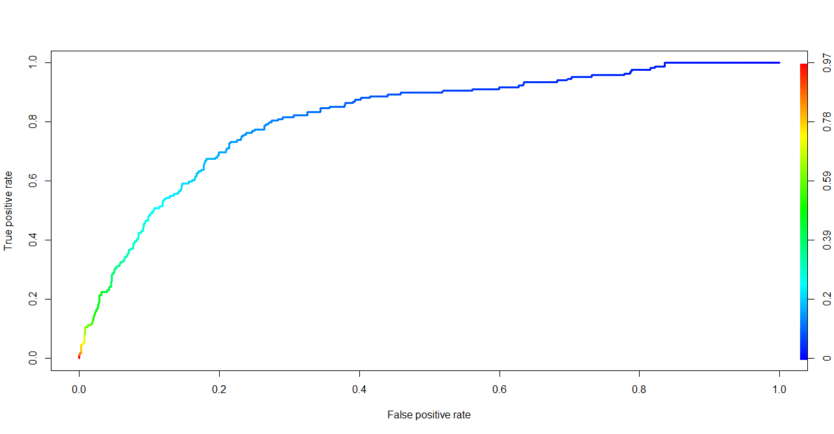
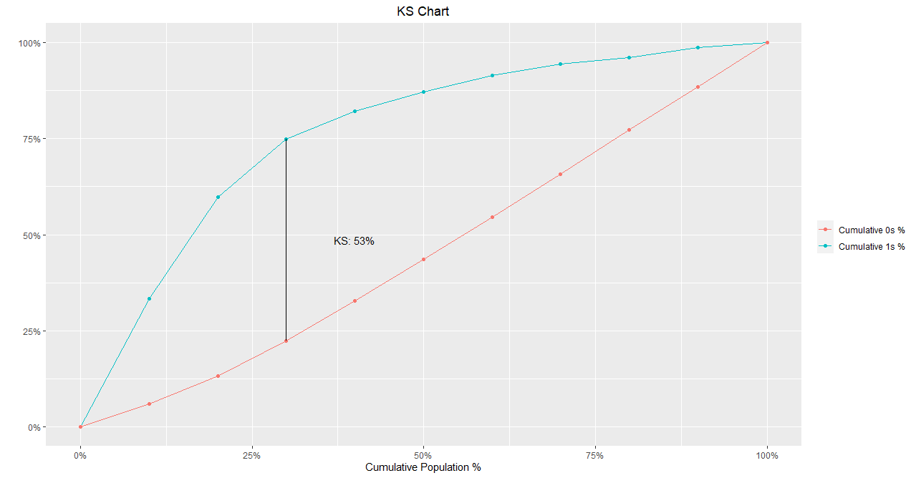
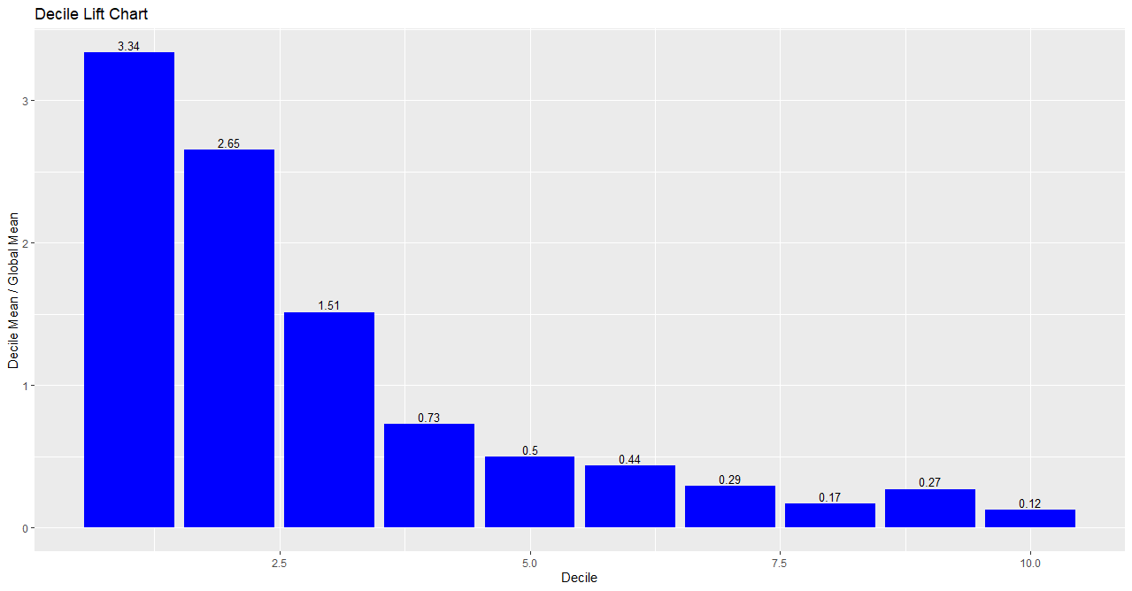

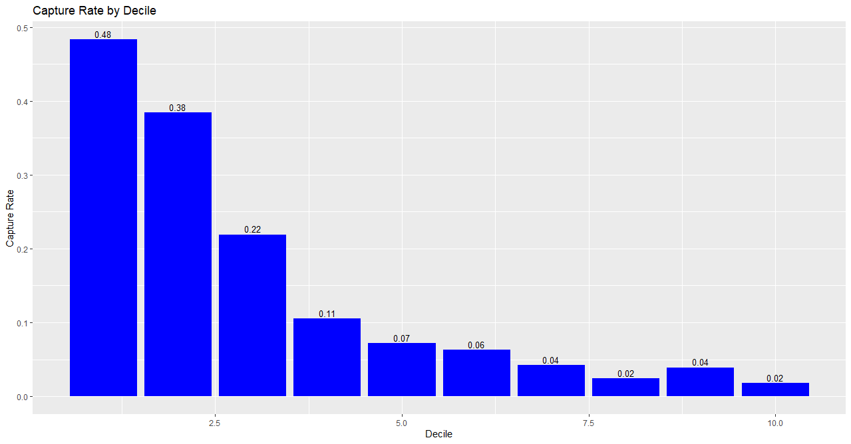
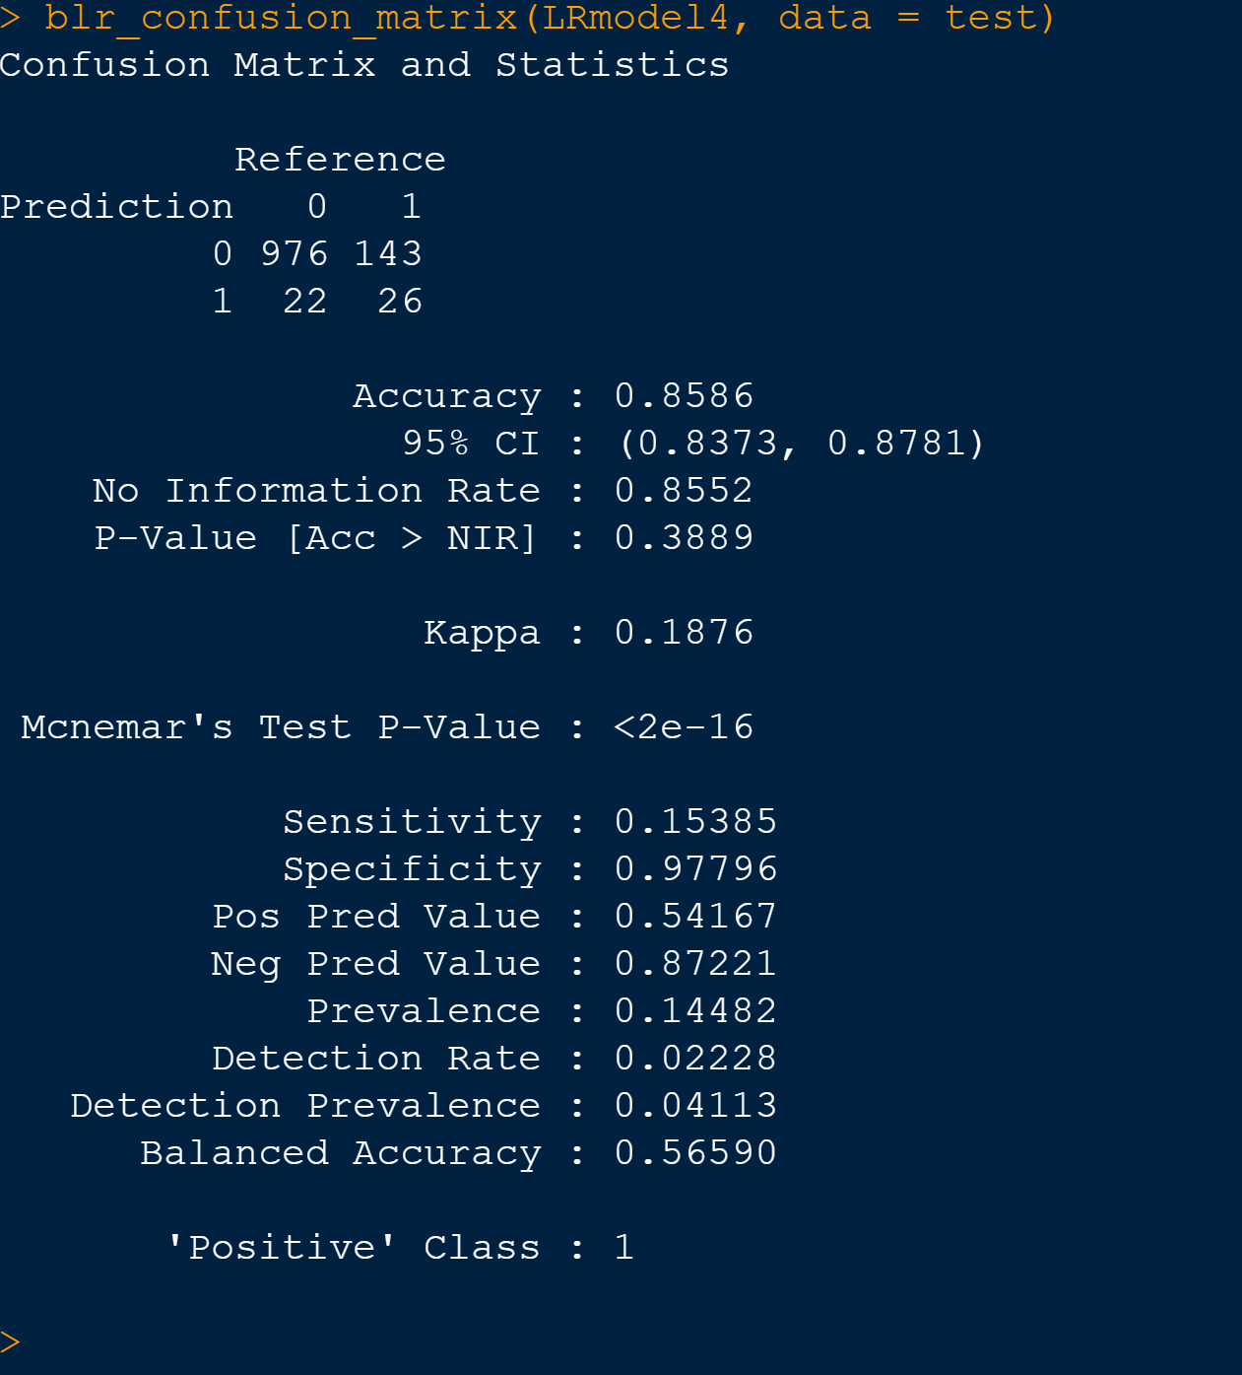

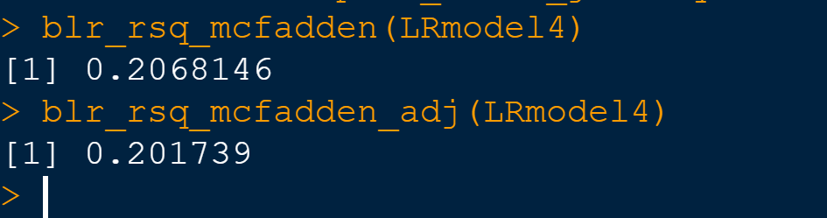

Model Output

KNN Model: K nearest neighbors is a simple algorithm that stores all available cases and classifies new cases based on a similarity measure.

We will be splitting our data into train and test with a split of 65:35 and first train our model with 65 percentage of the data set and finally test it with remaining 35 percentage.These calculations are included in the model performance section

Initially we performed the KNN analysis with train data which has a total of 2166 observations(65% of the data). And then it will be applied on test data. We will use a KNN train function to arrive at the optimum no: of K which we found to be ‘5’. Finally the Confusion matrix is plotted with the details.

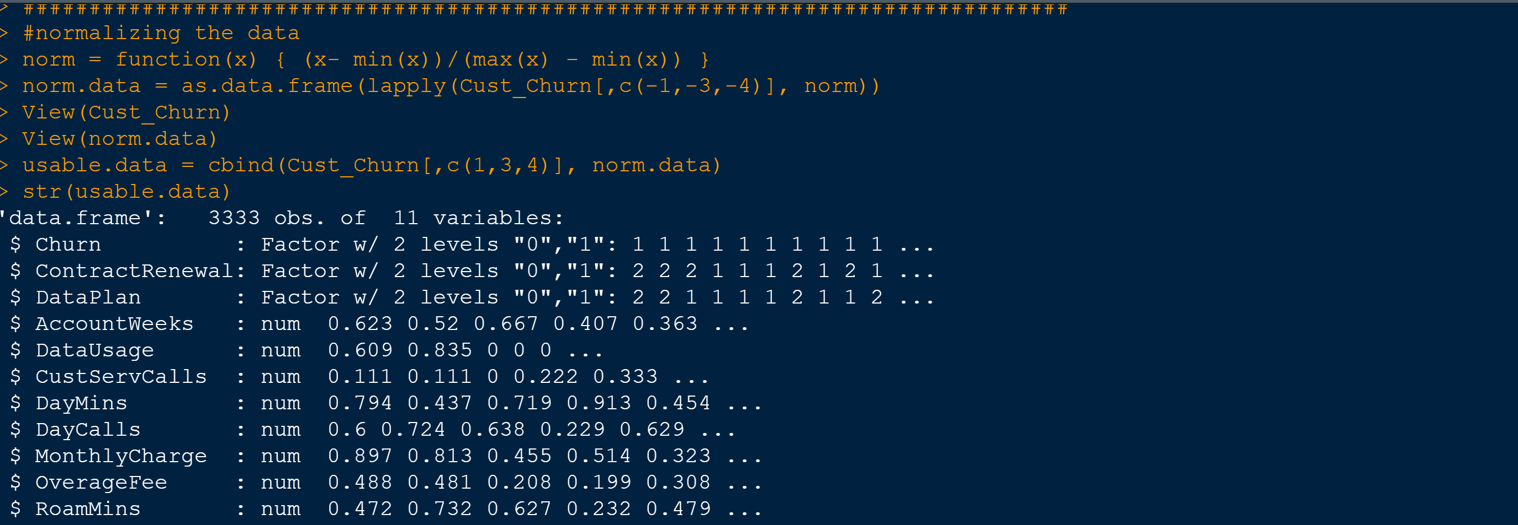

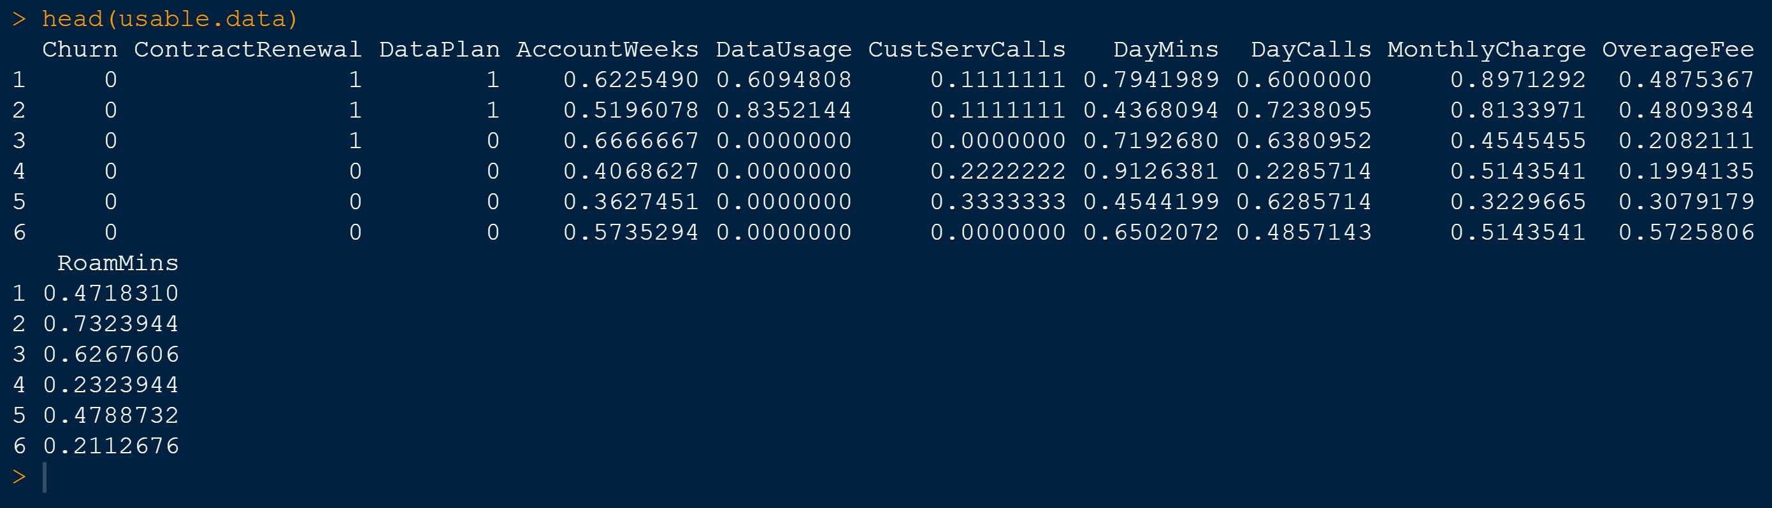

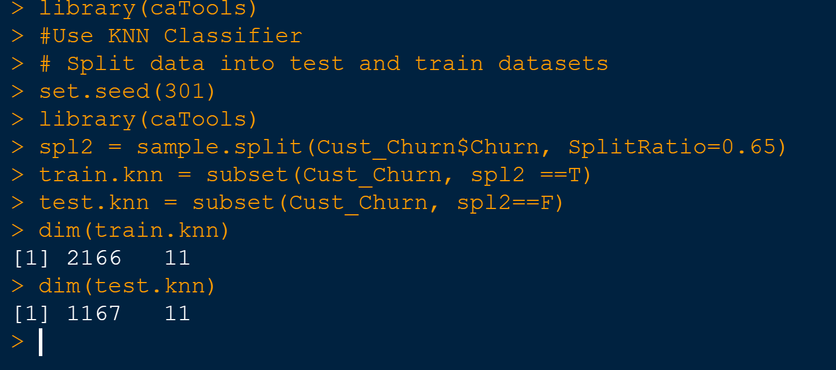

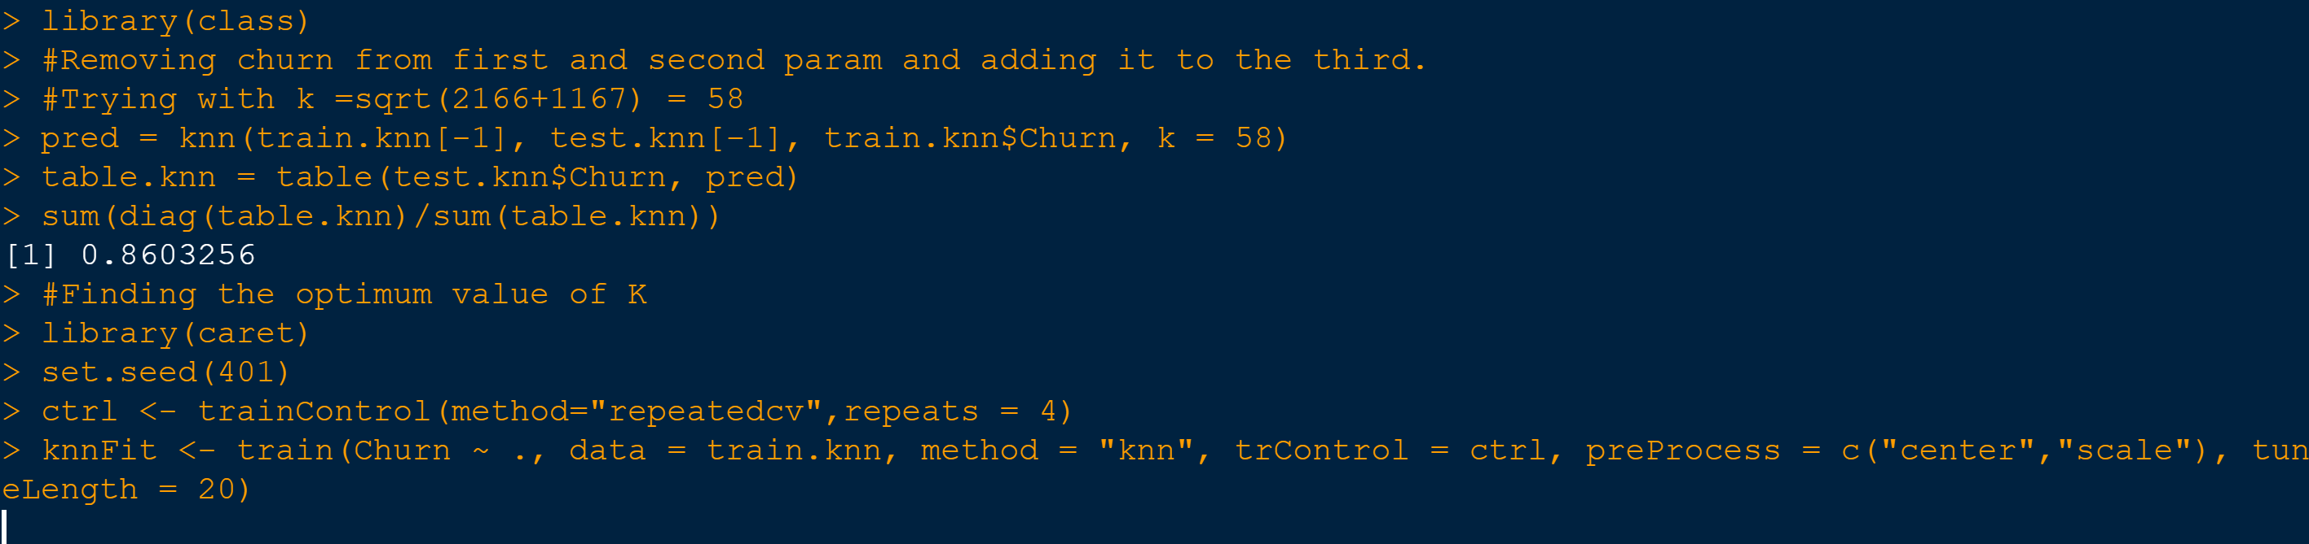

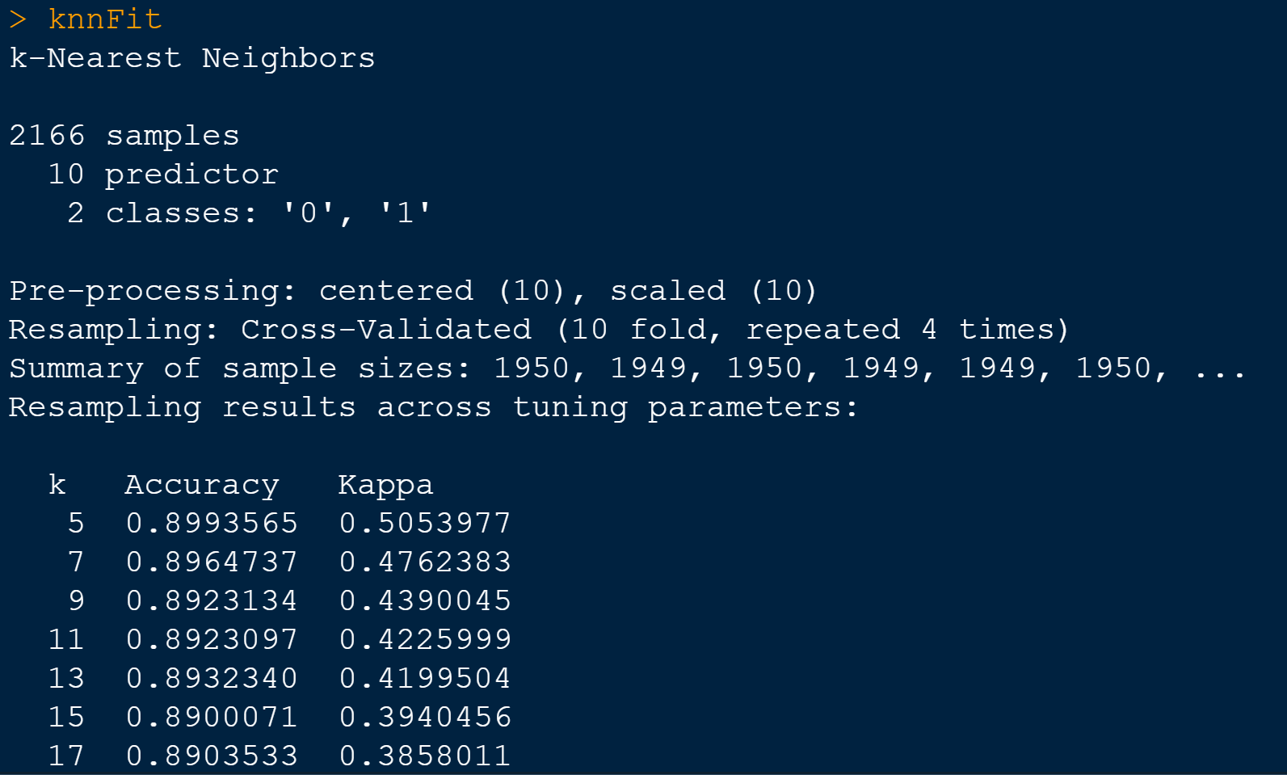

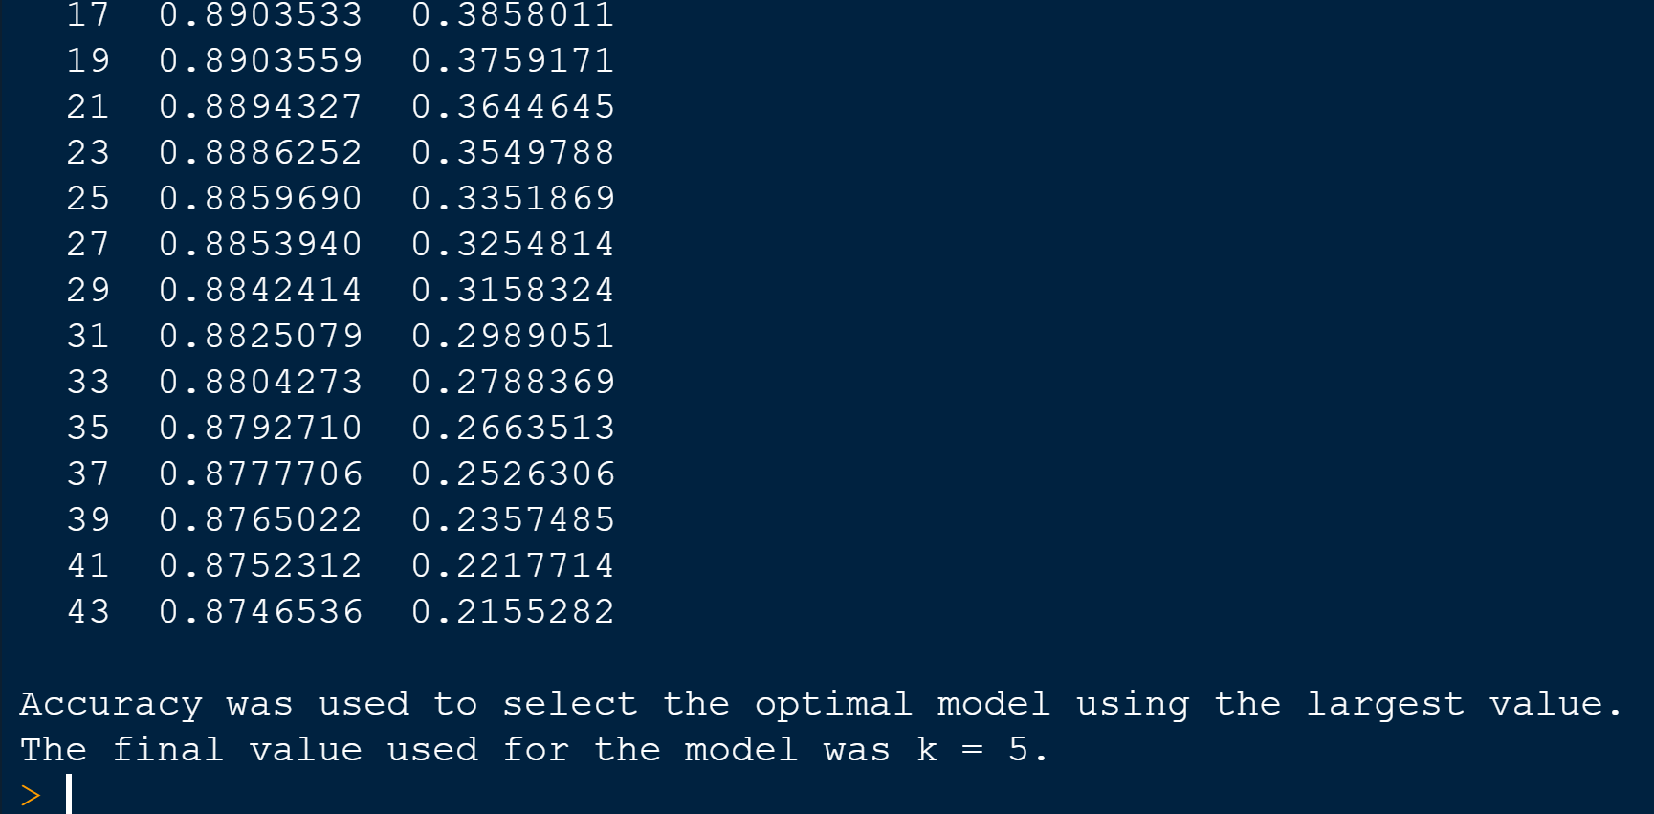

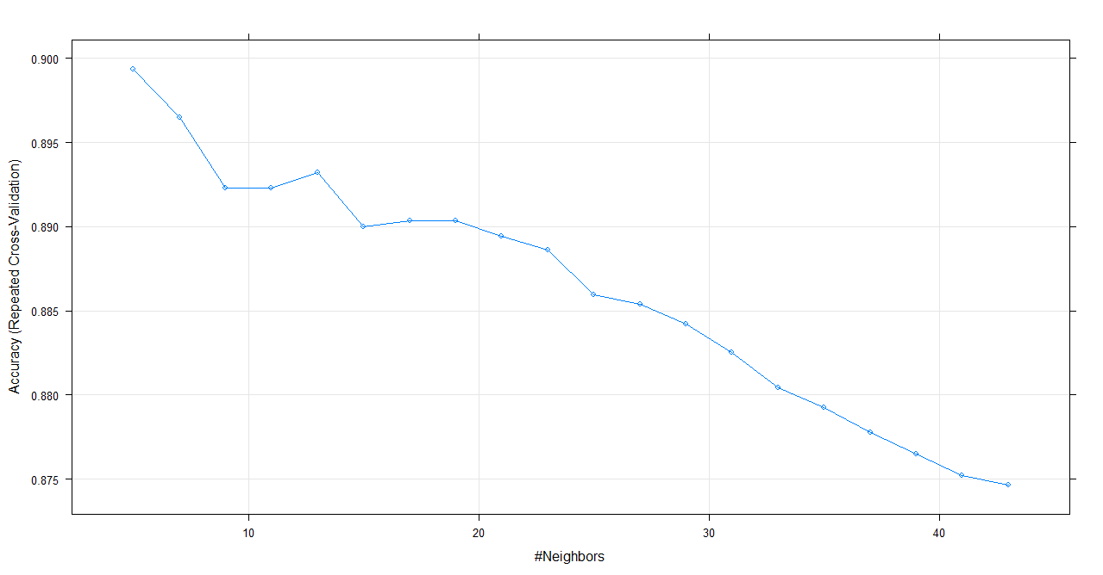
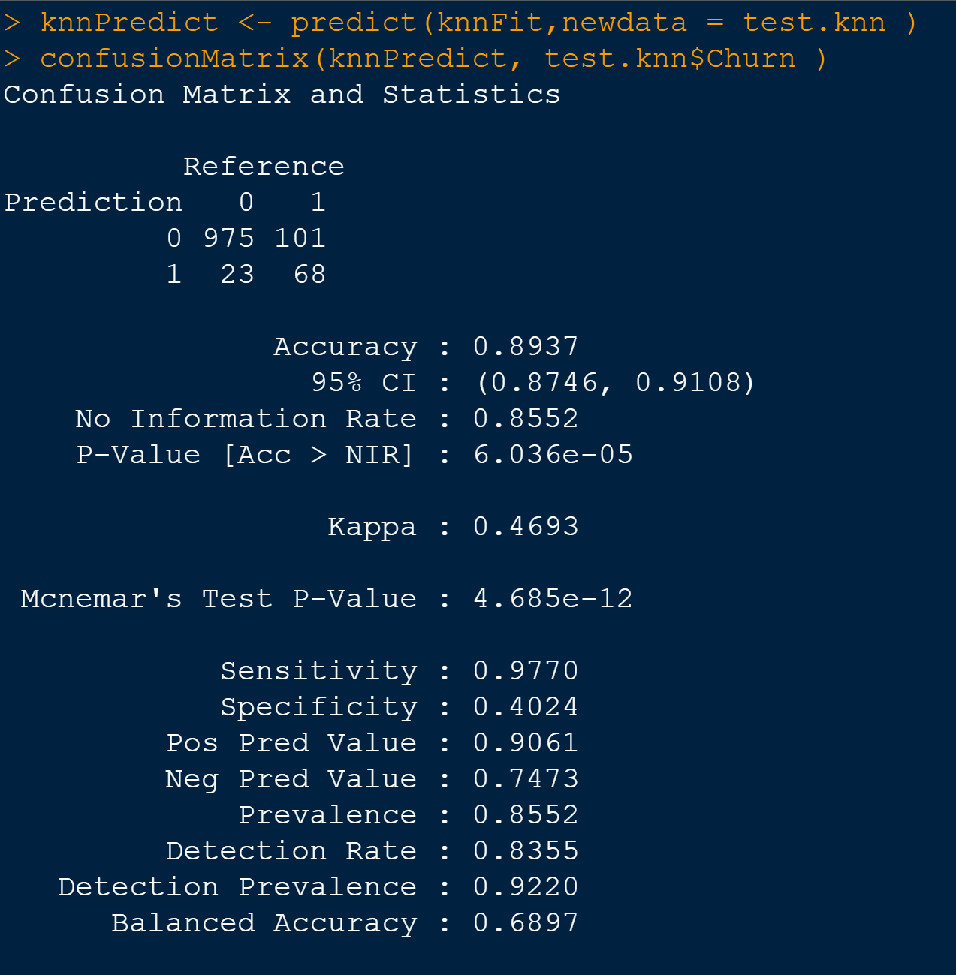

3.5 Applying Naive Bayes:
It is a classification technique based on Bayes' Theorem with an assumption of independence among predictors. In simple terms, a Naive Bayes classifier assumes that the presence of a particular feature in a class is unrelated to the presence of any other feature.

Since we assume non multicollinear dataset, we will use the data set after removing dependent variables

We will be splitting our data into train and test with a split of 65:35 and first train our model with 65 percentage of the data set and finally test it with remaining 35 percentage.These calculations are included in the model performance section

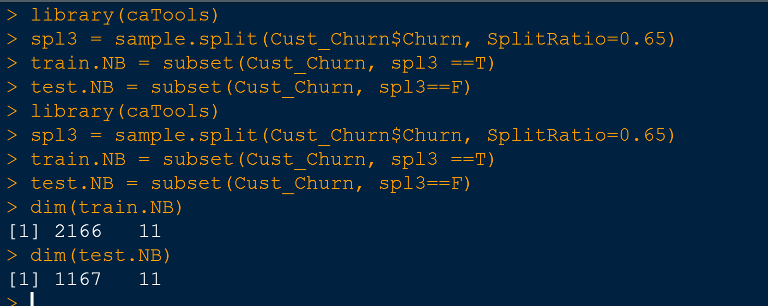

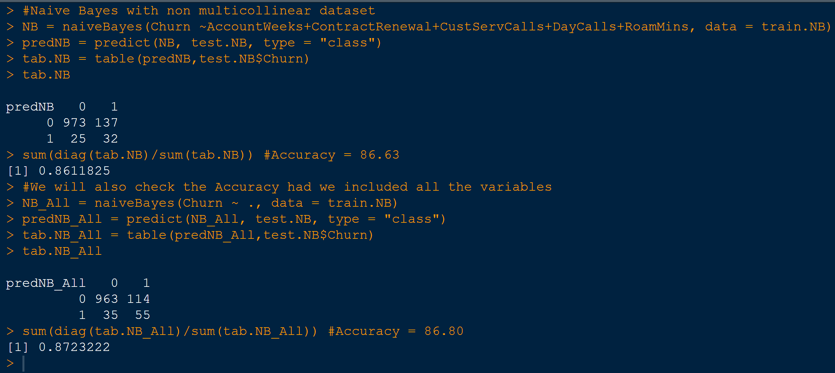

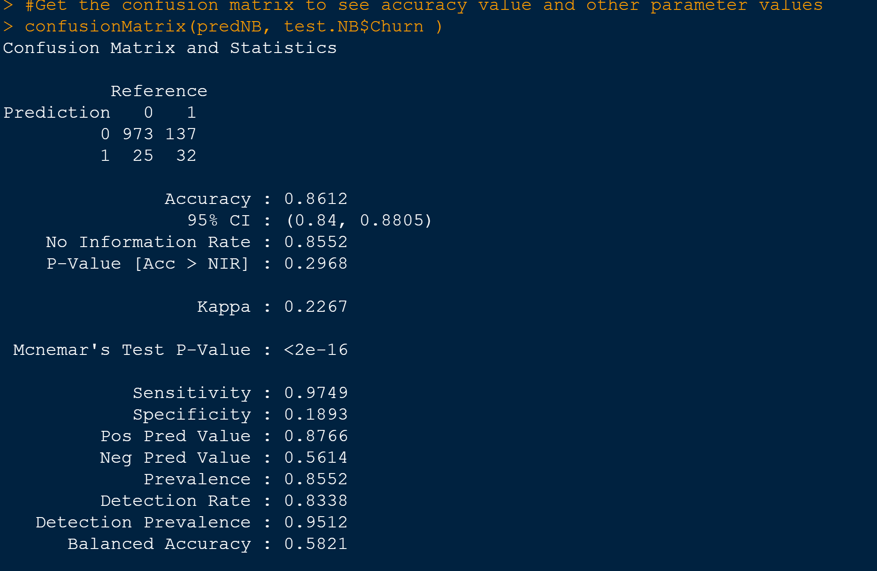

3.6.1 Model Comparison using Model Performance metrics & Interpretation
Confusion matrix interpretation for all models

Here is the tabular format for the performance of all these models.The highlighted in green are the winner in each category.

Logistic Regression | KNN | Naive Bayes
Accuracy : 0.8586 | Accuracy : 0.8937 | Accuracy : 0.8663
95% CI : (0.8373, 0.8781) | 95% CI : (0.8746, 0.9108) | 95% CI : (0.8454, 0.8853)
No Information Rate : 0.8552 | No Information Rate : 0.8552 | No Information Rate : 0.8552
P-Value [Acc > NIR] : 0.3889 | P-Value [Acc > NIR] : 6.036e-05 | P-Value [Acc > NIR] : 0.149
Kappa : 0.1876 | Kappa : 0.4693 | Kappa : 0.2451
Mcnemar's Test P-Value : <2e-16 | Mcnemar's Test P-Value : 4.685e-12 | Mcnemar's Test P-Value : <2e-16
Sensitivity : 0.15385 | Sensitivity : 0.9770 | Sensitivity : 0.9800
Specificity : 0.97796 | Specificity : 0.4024 | Specificity : 0.1953
Pos Pred Value : 0.54167 | Pos Pred Value : 0.9061 | Pos Pred Value : 0.8779
Neg Pred Value : 0.87221 | Neg Pred Value : 0.7473 | Neg Pred Value : 0.6226
Prevalence : 0.14482 | Prevalence : 0.8552 | Prevalence : 0.8552
Detection Rate : 0.02228 | Detection Rate : 0.8355 | Detection Rate : 0.8380
Detection Prevalence : 0.04113 | Detection Prevalence : 0.9220 | Detection Prevalence : 0.9546
Balanced Accuracy : 0.56590 | Balanced Accuracy : 0.6897 | Balanced Accuracy : 0.5876

3.6.2 Interpretation of other Model Performance Measures for logistic <KS, AUC, GINI>

We use a number of model performance measures to assess the performance of the models.

Some of these measures used for the dataset are below -
- ROC Curve/AUC - As the threshold changes, a plot of the false positive rate vs true positive rate is called the ROC curve -Receiver Operating Characteristic. Area under the curve (AUC) is a measure of how good the model is predicting the data.It explains the trade-off between true positive rate (Sensitivity) and false positive rate (1-Specificity)
- KS (Kolmogorov-Smirnov) statistic - KS Test measures to check whether model is able to separate events and non-events. In probability of default (bank defaulters) model, it checks whether the model is able to distinguish between customers who will/will not take loan. The calculation of KS test is explained below -KS = Maximum difference between Cumulative % Event and Cumulative Non-Event
- Gini Index - The Gini index measures the extent to which the distribution of data deviates from a perfectly equal distribution. A Gini index of zero represents perfect equality and 100 for perfect inequality.
Lift Chart- The x-axis shows the percentile and the y-axis shows lift cumulative. Not that the default (no model), is a horizontal line intersecting the y-axis at 1. If we contact a random 10% of the population using no model, we should get 10% of the at-risk customers by default (or lift=1).

These model performance measures were applied on the Logistic Regression model and we got the below values for the same
KS - 53% for LR
AUC- 0.815
Gini - 0.53
Lift Gain - 3.35

The above measures using Logistic Regression were only just average and doesnt indicate a superior model performance.

3.6.3 Remarks on Model validation exercise <Which model performed the best>
After performing our analysis with different models - LR, KNN & NB, from an accuracy perspective, the KNN was better among the three.Also the Kappa & P-Value value was better for KNN. The metric Sensitivity was sligtly better for Naive Bayes when compared to KNN, however Positive Prediction values were much better for KNN and negative prediction values for LR. SO LR did a good job in predicting negative prediction value, but failed badly with positive prediction values. So from an overall perspective and from a balanced accuracy standpoint, we would select KNN as the winner among the 3 models due to its good accuracy rate and decent performance with other metrics as well.

3.6.4 Interpretation & Recommendations from the best model

As mentioned above, we performed model analysis with 3models - LR, KNN & Naive Bayes for each of the Train & test data sets and compared the results. We did this by segregating the data into train and test with 65:35split and analyzing performance on test category after validating the model with train data.From a model perspective, it was very clear that the KNN performed much better than the other models. The accuracy of the model was good and close to 90%. One recommendation would be that we could avoid some variables since multi collinearity exists in this data set.Also another insight is that our winner model performed very good wrt sensitivity (97%), but specificity was below average ( 40%). Also though our models positive prediction rate was good(90%), the negative prediction lacks a bit (74%). So we might want to test the model with more data. Also we can vary the k parameter to see the best fit that we can find wrt Accuracy, Sensitivity, Specificity. Another recommendation taht we could provide is by varying the train-test data proportion and see how the results vary.

3.7 Appendix A:

######################################################################
###########################CUSTOMER CHURN SOLUTION########################
######################################################################

#Install packages
install.packages("readxl")
install.packages("ggplot2")
install.packages("caTools")
install.packages("ROCR")
install.packages("ineq")
install.packages("caret")

#Load libraries
library(ggplot2)
library(readxl)
library(corrplot)
library(caTools)
library(caret)
library(blorr)

# Set the working directory and check it
setwd("C:/2020/RProgramming/Predictive_Modeling")
getwd()

#Import the data
Cust_Churn <- read_excel("C:/2020/RProgramming/Predictive_Modeling/Cellphone.xlsx", sheet=2)
View(Cust_Churn)

##Check the dimension or shape of the data
dim(Cust_Churn)
str(Cust_Churn)

##Convert all variables into factors where necessary.
#library(dplyr)
Cust_Churn$Churn <- as.factor(Cust_Churn$Churn)
Cust_Churn$ContractRenewal <- as.factor(Cust_Churn$ContractRenewal)
Cust_Churn$DataPlan <- as.factor(Cust_Churn$DataPlan)

str(Cust_Churn)
#Perform basic summary
head(Cust_Churn)
tail(Cust_Churn)
summary(Cust_Churn)

##View top 5 rows
Cust_Churn[1:5,]

##Lets see the variable list in the data and then make changes to the col names
names(Cust_Churn)

#Checking for Missing values9NA) in each of the columns
apply(Cust_Churn,2,function(x) sum(is.na(x)))
sum(is.na(Cust_Churn))

str(Cust_Churn)
## list out all the numeric and categorical variables and their levels
split(names(Cust_Churn),sapply(Cust_Churn, function(x) paste(class(x), collapse=" ")))

##Summary Statistics Measure of central tendency and dispersion (Univariate Analysis)
##(count,missing value,mean,0.01,0.05,0.10,0.25,Median,0.75,0.90,0.95,0.99,min,max,range,skew,kurtosis,
#SD,IQR) for continous variable
names(Cust_Churn)
boxplot(Cust_Churn$AccountWeeks)
boxplot(Cust_Churn$DataUsage)
boxplot(Cust_Churn$DayMins)
boxplot(Cust_Churn$DayCalls)
boxplot(Cust_Churn$MonthlyCharge)
boxplot(Cust_Churn$OverageFee)
boxplot(Cust_Churn$RoamMins)

length(boxplot.stats(Cust_Churn$AccountWeeks)$out)
length(boxplot.stats(Cust_Churn$DataUsage)$out)
length(boxplot.stats(Cust_Churn$DayMins)$out)
length(boxplot.stats(Cust_Churn$DayCalls)$out)
length(boxplot.stats(Cust_Churn$MonthlyCharge)$out)
length(boxplot.stats(Cust_Churn$OverageFee)$out)
length(boxplot.stats(Cust_Churn$RoamMins)$out)

#For missing values that lie outside the 1.5 * IQR limits, we could cap it by replacing those observations outside the lower limit with the value of 5th %ile and those that lie
#above the upper limit, with the value of 95th %ile. Below is a sample code that achieves this.
##Outlier Treatment for AccountWeeks variable

qnt <- quantile(Cust_Churn$AccountWeeks, probs=c(.25, .75), na.rm = T)
caps <- quantile(Cust_Churn$AccountWeeks, probs=c(.05, .95), na.rm = T)
H <- 1.5 * IQR(Cust_Churn$AccountWeeks, na.rm = T)

Cust_Churn$AccountWeeks[Cust_Churn$AccountWeeks < (qnt[1] - H)] <- caps[1]
Cust_Churn$AccountWeeks[Cust_Churn$AccountWeeks > (qnt[2] + H)] <- caps[2]
summary(Cust_Churn$AccountWeeks)
length(boxplot.stats(Cust_Churn$AccountWeeks)$out)

############################################
## Outlier Treatment for DataUsage variable
qnt <- quantile(Cust_Churn$DataUsage, probs=c(.25, .75), na.rm = T)
caps <- quantile(Cust_Churn$DataUsage, probs=c(.05, .95), na.rm = T)
H <- 1.5 * IQR(Cust_Churn$DataUsage, na.rm = T)

Cust_Churn$DataUsage[Cust_Churn$DataUsage < (qnt[1] - H)] <- caps[1]
Cust_Churn$DataUsage[Cust_Churn$DataUsage > (qnt[2] + H)] <- caps[2]
summary(Cust_Churn$DataUsage)
length(boxplot.stats(Cust_Churn$DataUsage)$out)

## Outlier Treatment for DayMins variable
qnt <- quantile(Cust_Churn$DayMins, probs=c(.25, .75), na.rm = T)
caps <- quantile(Cust_Churn$DayMins, probs=c(.05, .95), na.rm = T)
H <- 1.5 * IQR(Cust_Churn$DayMins, na.rm = T)

Cust_Churn$DayMins[Cust_Churn$DayMins < (qnt[1] - H)] <- caps[1]
Cust_Churn$DayMins[Cust_Churn$DayMins > (qnt[2] + H)] <- caps[2]
summary(Cust_Churn$DayMins)
length(boxplot.stats(Cust_Churn$DayMins)$out)

## Outlier Treatment for DayCalls variable
qnt <- quantile(Cust_Churn$DayCalls, probs=c(.25, .75), na.rm = T)
caps <- quantile(Cust_Churn$DayCalls, probs=c(.05, .95), na.rm = T)
H <- 1.5 * IQR(Cust_Churn$DayCalls, na.rm = T)

Cust_Churn$DayCalls[Cust_Churn$DayCalls < (qnt[1] - H)] <- caps[1]
Cust_Churn$DayCalls[Cust_Churn$DayCalls > (qnt[2] + H)] <- caps[2]
summary(Cust_Churn$DayCalls)
length(boxplot.stats(Cust_Churn$DayCalls)$out)

## Outlier Treatment for MonthlyCharge variable
qnt <- quantile(Cust_Churn$MonthlyCharge, probs=c(.25, .75), na.rm = T)
caps <- quantile(Cust_Churn$MonthlyCharge, probs=c(.05, .95), na.rm = T)
H <- 1.5 * IQR(Cust_Churn$MonthlyCharge, na.rm = T)

Cust_Churn$MonthlyCharge[Cust_Churn$MonthlyCharge < (qnt[1] - H)] <- caps[1]
Cust_Churn$MonthlyCharge[Cust_Churn$MonthlyCharge > (qnt[2] + H)] <- caps[2]
summary(Cust_Churn$MonthlyCharge)
length(boxplot.stats(Cust_Churn$MonthlyCharge)$out)

## Outlier Treatment for OverageFee variable
qnt <- quantile(Cust_Churn$OverageFee, probs=c(.25, .75), na.rm = T)
caps <- quantile(Cust_Churn$OverageFee, probs=c(.05, .95), na.rm = T)
H <- 1.5 * IQR(Cust_Churn$OverageFee, na.rm = T)

Cust_Churn$OverageFee[Cust_Churn$OverageFee < (qnt[1] - H)] <- caps[1]
Cust_Churn$OverageFee[Cust_Churn$OverageFee > (qnt[2] + H)] <- caps[2]
summary(Cust_Churn$OverageFee)
length(boxplot.stats(Cust_Churn$OverageFee)$out)

## Outlier Treatment for RoamMins variable
qnt <- quantile(Cust_Churn$RoamMins, probs=c(.25, .75), na.rm = T)
caps <- quantile(Cust_Churn$RoamMins, probs=c(.05, .95), na.rm = T)
H <- 1.5 * IQR(Cust_Churn$RoamMins, na.rm = T)

Cust_Churn$RoamMins[Cust_Churn$RoamMins < (qnt[1] - H)] <- caps[1]
Cust_Churn$RoamMins[Cust_Churn$RoamMins > (qnt[2] + H)] <- caps[2]
summary(Cust_Churn$RoamMins)
length(boxplot.stats(Cust_Churn$RoamMins)$out)

# Checking the Summary and Structure of dataset after making doing the treatments
summary(Cust_Churn)
str(Cust_Churn)

## Univariate Analysis
plot_intro(Cust_Churn)
plot_histogram(Cust_Churn)
plot_bar(Cust_Churn, title="Categorical variables in Cust_Churn Dataset")
## Bivariate Analysis

#Boxplots
names(Cust_Churn)

### Few boxplots
boxplot(Cust_Churn[c(2,5,6:11)],
las=1,
horizontal = TRUE,
cex= 0.8,
par(cex.axis = 0.8),
col=brewer.pal(8,"Set1"),
main = "Boxplots of continous variables")

boxplot(Cust_Churn$AccountWeeks, main="Boxplot of AccountWeeks")
boxplot(Cust_Churn$DataUsage, main="Boxplot of DataUsage")
boxplot(Cust_Churn$CustServCalls, main="Boxplot of CustServCalls")
boxplot(Cust_Churn$DayMins, main="Boxplot of DayMins")
boxplot(Cust_Churn$DayCalls, main="Boxplot of DayCalls")
boxplot(Cust_Churn$MonthlyCharge, main="Boxplot of MonthlyCharge")
boxplot(Cust_Churn$OverageFee, main="Boxplot of OverageFee")
boxplot(Cust_Churn$RoamMins, main="Boxplot of RoamMins")

ggplot(Cust_Churn, aes(AccountWeeks, fill= Churn)) + geom_density(alpha=0.5)
ggplot(Cust_Churn, aes(DataUsage, fill= Churn)) + geom_density(alpha=0.5)
ggplot(Cust_Churn, aes(CustServCalls, fill= Churn)) + geom_density(alpha=0.5)
ggplot(Cust_Churn, aes(DayMins, fill= Churn)) + geom_density(alpha=0.5)
ggplot(Cust_Churn, aes(DayCalls, fill= Churn)) + geom_density(alpha=0.5)
ggplot(Cust_Churn, aes(MonthlyCharge, fill= Churn)) + geom_density(alpha=0.5)
ggplot(Cust_Churn, aes(OverageFee, fill= Churn)) + geom_density(alpha=0.5)
ggplot(Cust_Churn, aes(RoamMins, fill= Churn)) + geom_density(alpha=0.5)

#Multi Boxplot
plot_boxplot(Cust_Churn[c(-3,-4)], by="Churn")

#Scatter Plots
plot(Cust_Churn$DataUsage, Cust_Churn$RoamMins)
plot(Cust_Churn$DataUsage, Cust_Churn$MonthlyCharge)
plot(Cust_Churn$DayMins, Cust_Churn$MonthlyCharge)
plot(Cust_Churn$OverageFee, Cust_Churn$MonthlyCharge)

#Check for Multicollinearity
pairs(Cust_Churn[c(-1,-3,-4)], pch=15, col=c("darkblue","magenta","dark green"))
##correlation between continous variables (Multi variate Analysis)
plot_correlation(Cust_Churn[ ,c(2,5:11)])
##correlation between continous variables
cor(Cust_Churn[ ,c(2,5:11)])

# Treatment for Multicollinearity
set.seed(300)
LRmodel_mc = glm(Churn ~ ., data = Cust_Churn, family= binomial)
summary(LRmodel_mc)
car::vif(LRmodel_mc)
#Treatment - We will remove the variables which has a VIF > 5 . These are MonthyCharge,
#DataUsage,DayMins,DataPlan,OverageFee
LRmodel_mc_treated = glm(Churn ~ AccountWeeks+ContractRenewal+CustServCalls+DayCalls+RoamMins , data = Cust_Churn, family= binomial)
summary(LRmodel_mc_treated)
car::vif(LRmodel_mc_treated)
##################################################################################################

#################################################################################
#### build univariate logistic regression models and check results
mod.num1 <- glm(Churn~AccountWeeks, data = Cust_Churn, family = binomial)
summary(mod.num1)
# AccountWeeks is NOT a significant variable

mod.num2 <- glm(Churn~ContractRenewal , data = Cust_Churn, family = binomial)
summary(mod.num2)
# ContractRenewal is a significant variable

mod.num3 <- glm(Churn~CustServCalls , data = Cust_Churn, family = binomial)
summary(mod.num3)
# CustServCalls is a significant variable

mod.num4 <- glm(Churn~DayMins , data = Cust_Churn, family = binomial)
summary(mod.num4)
# DayMins is a significant variable

mod.num5 <- glm(Churn~DayCalls , data = Cust_Churn, family = binomial)
summary(mod.num5)
# DayCalls is NOT a significant variable

mod.num6 <- glm(Churn~MonthlyCharge , data = Cust_Churn, family = binomial)
summary(mod.num6)
# MonthlyCharge is a significant variable

mod.num7 <- glm(Churn~OverageFee , data = Cust_Churn, family = binomial)
summary(mod.num7)
# OverageFee is a significant variable

mod.num8 <- glm(Churn~RoamMins , data = Cust_Churn, family = binomial)
summary(mod.num8)
# RoamMins is a significant variable

mod.fact1 <- glm(Churn~ContractRenewal , data = Cust_Churn, family = binomial)
summary(mod.fact1)
# ContractRenewal is a significant variable

mod.fact2 <- glm(Churn~DataPlan , data = Cust_Churn, family = binomial)
summary(mod.fact2)
# DataPlan is a significant variable
###########################################################################################

# Now we can build the full model

# Split data into test and train datasets
set.seed(300)
library(caTools)
spl = sample.split(Cust_Churn$Churn, SplitRatio=0.65)
train = subset(Cust_Churn, spl ==T)
test = subset(Cust_Churn, spl==F)

dim(train)
dim(test)
## Check split consistency
#sum(as.integer(as.character(train$TenYearCHD))) / nrow(train)
sum(as.integer(as.character(train$Churn))) / nrow(train)
sum(as.integer(as.character(test$Churn))) / nrow(test)
sum(as.integer(as.character(Cust_Churn$Churn))) / nrow(Cust_Churn)

# build the model with all variables
set.seed(300)
LRmodel1 = glm(Churn ~ ., data = train, family= binomial)
summary(LRmodel1)

predTest1 = predict(LRmodel1, newdata= test, type="response")
table(test$Churn, predTest1>0.5)
(977+23)/nrow(na.omit(test)) #Accuracy= 85.68%

# build the model after omitting variables with high VIF's -MonthlyCharge,DataUsage,DayMins,DataPlan,OverageFee
set.seed(301)
LRmodel2 = glm(Churn ~ AccountWeeks+ContractRenewal+CustServCalls+RoamMins+DayCalls, data = train, family= binomial)
summary(LRmodel2)

predTest2 = predict(LRmodel2, newdata= test, type="response")
table(test$Churn, predTest2>0.5)
(982+21)/nrow(na.omit(test)) #= 85.95%

# From output we see that AccountWeeks & DayCalls are not significant variables.So re running
#the model after removing the insignificant variables.
LRmodel3 = glm(Churn ~ ContractRenewal+CustServCalls+RoamMins, data = train, family= binomial)
summary(LRmodel3)

predTest3 = predict(LRmodel3, newdata= test, type="response")
table(test$Churn, predTest3>0.5)
(983+21)/nrow(na.omit(test)) #= 86.03%

## Finally we use library blorr to build and validate binary logistic models
library(blorr)
#We pass the output of model where all variables were taken into account to blr_step_aic_both() function
blr_step_aic_both(LRmodel1, details = FALSE)
#Based on the output from blorr, we run the LR model for the 4th time
set.seed(400)
LRmodel4 <- glm(Churn~ContractRenewal+CustServCalls+DataPlan+MonthlyCharge+RoamMins+DataUsage, data = Cust_Churn, family = binomial)
summary(LRmodel4)
predTest4 = predict(LRmodel4, newdata= test, type="response")
table(test$Churn, predTest4>0.5)
#(976+26)/nrow(na.omit(test)) = 85.86%

###############################################################################################
#Of all the iterations that we performed, the accuracy was best for the model where we removed
#multicollinear and insignificant variables.However the difference was very marginal and also
#since we know that Multicollinearity is not a parameter that really affects Accuracy, we
#will take that model output that was given by blorr() function (LRmodel4) and
#perform other model performance measures on it for the test dataset.
###############################################################################################
library(ROCR)
ROCRpred = prediction(predTest4, test$Churn)
as.numeric(performance(ROCRpred, "auc")@y.values)
perf = performance(ROCRpred, "tpr","fpr")
plot(perf,col="black",lty=2, lwd=2)
plot(perf,lwd=3,colorize = TRUE)

k <- blr_gains_table(LRmodel4)
plot(k)

blr_ks_chart(k, title = "KS Chart",
yaxis_title = " ",xaxis_title = "Cumulative Population %",
ks_line_color = "black")

blr_decile_lift_chart(k, xaxis_title = "Decile",
yaxis_title = "Decile Mean / Global Mean",
title = "Decile Lift Chart",
bar_color = "blue", text_size = 3.5,
text_vjust = -0.3)

blr_decile_capture_rate(k, xaxis_title = "Decile",
yaxis_title = "Capture Rate",
title = "Capture Rate by Decile",
bar_color = "blue", text_size = 3.5,
text_vjust =-0.3)

blr_confusion_matrix(LRmodel4, data = test)

blr_gini_index(LRmodel4, data = Cust_Churn)

blr_roc_curve(k, title = "ROC Curve",
xaxis_title = "1 - Specificity",
yaxis_title = "Sensitivity",roc_curve_col = "blue",
diag_line_col = "red", point_shape = 18,
point_fill = "blue", point_color = "blue",
plot_title_justify = 0.5)

blr_rsq_mcfadden(LRmodel4)
blr_rsq_mcfadden_adj(LRmodel4)

blr_plot_difchisq_fitted(LRmodel4, point_color = "blue",
title = "Delta Chi Square vs Fitted Values Plot",
xaxis_title = "Fitted Values",
yaxis_title = "Delta Chi Square")

###############################################################################
###########################KNN MODEL###########################################
###############################################################################

#normalizing the data
norm = function(x) { (x- min(x))/(max(x) - min(x)) }
norm.data = as.data.frame(lapply(Cust_Churn[,c(-1,-3,-4)], norm))
View(Cust_Churn)
View(norm.data)
usable.data = cbind(Cust_Churn[,c(1,3,4)], norm.data)
str(usable.data)
head(usable.data)
# Data partitioning
library(caTools)
#Use KNN Classifier
# Split data into test and train datasets
set.seed(300)
library(caTools)
spl2 = sample.split(Cust_Churn$Churn, SplitRatio=0.65)
train.knn = subset(Cust_Churn, spl2 ==T)
test.knn = subset(Cust_Churn, spl2==F)
dim(train.knn)
dim(test.knn)

library(class)
#Removing churn from first and second param and adding it to the third.
#Trying with k =sqrt(2166+1167) = 58
pred = knn(train.knn[-1], test.knn[-1], train.knn$Churn, k = 58)
table.knn = table(test.knn$Churn, pred)
sum(diag(table.knn)/sum(table.knn))

#Finding the optimum value of K
library(caret)
set.seed(401)
ctrl <- trainControl(method="repeatedcv",repeats = 3)
knnFit <- train(Churn ~ ., data = train.knn, method = "knn", trControl = ctrl, preProcess = c("center","scale"), tuneLength = 20)

#Output of kNN fit
knnFit
plot(knnFit)
dim(train)
dim(test)
pred.knn = knn(train.knn[-1], test.knn[-1], train.knn$Churn, k = 5)
table.knn = table(test.knn$Churn, pred.knn)
table.knn
sum(diag(table.knn)/sum(table.knn)) #
#(971+43)/(976+91+22+78) Accuracy = 86.88%

knnPredict <- predict(knnFit,newdata = test.knn )
#Get the confusion matrix to see accuracy value and other parameter values
confusionMatrix(knnPredict, test.knn$Churn )

################################################################################
############################NAIVE BAYES MODEL###################################
################################################################################
names(Cust_Churn)
head(Cust_Churn)
head(train)
head(test)
library(e1071)
# Since Naive Bayes is impacted by multicollinearity, we will remove high vif variables value from the dataset.
# Variables impacted by Multi collinearity - MonthyCharge,DataUsage,DayMins,DataPlan,OverageFee
# Split data into test and train datasets
set.seed(300)
library(caTools)
spl3 = sample.split(Cust_Churn$Churn, SplitRatio=0.65)
train.NB = subset(Cust_Churn, spl3 ==T)
test.NB = subset(Cust_Churn, spl3==F)
dim(train.NB)
dim(test.NB)

NB = naiveBayes(Churn ~AccountWeeks+ContractRenewal+CustServCalls+DayCalls+RoamMins, data = train.NB)
predNB = predict(NB, test.NB, type = "class")
tab.NB = table(predNB,test.NB$Churn)
tab.NB
sum(diag(tab.NB)/sum(tab.NB)) #Accuracy = 86.63

#We will also check the Accuracy had we included all the variables
NB_All = naiveBayes(Churn ~ ., data = train.NB)
predNB_All = predict(NB_All, test.NB, type = "class")
tab.NB_All = table(predNB_All,test.NB$Churn)
tab.NB_All
sum(diag(tab.NB_All)/sum(tab.NB_All)) #Accuracy = 86.80

#Get the confusion matrix to see accuracy value and other parameter values
confusionMatrix(predNB, test.NB$Churn )

###################################THE END #######################################

